

Project n°: 295153

Room-temperature seismic attenuator
for the underground interferometer
KAGRA and ET perspective
.

WP1 - 24 moths term

ET-0008A-14

Author: UNISANNIO,FOM and E.Majorana

Version: 1.0

Table of Contents
1 Introduction 1
2 Underground environment and seismic suspension 2
3 The suspension developed for KAGRA 4
4 Feasibility of cryogenic payload with low mechanical dissipation 5
Bibilography 6

1. Introduction
The first purpose of this document is to illustrate the design choices, construction and preliminary testing of the Seismic Attenuation System of KAGRA, called KAGRA-SAS. Some of the work for KAGRA has been done with the help of scientists from the European Union collaborating to KAGRA, but also with the purpose of contributing to the R&D necessary for the proposed Einstein Telescope, third generation Gravitational Wave detector. The second purpose of this chapter is therefore to describe the status-of–the art of seismic attenuation in view of Gravitational Wave Detectors of third generation, listing problem solved and developments still to be done to satisfy the expected requirements of future detectors. For this purpose, wherever relevant, wealso compare the design and results reported here with alternative solutions implemented elsewhere and with their results. KAGRA-SAS shares the same technologies and many of the components with theseismic tables of the ten-meter interferometer prototype at the Albert Einstein Institute (AEI-SAS), the Virgo injection bench (NIKHEF-SAS) and the Virgo auxiliary optics benches (Multi-SAS chains), also made at NIKHEF. Although separate chapters describe the floating, GAS-supported optical tables (used in the AEI 10 m and in the Virgo injection benches and their precursor HAM-SAS of LIGO) and the suspended optical tables (used in the NIKHEF Multi-SAS), some of the results achieved in those developments are reported in this chapter.

1.1 General considerations: KAGRA’s seismic attenuation pedigree

KAGRA shares with Virgo and TAMA the philosophy of passive seismic attenuation chains, each suspending a main optical component. The use of large vacuum chambers and optical tables suspending several components, including main optics is avoided. As will be shown in this chapter, this choice lends much greater flexibility to the facility, at a much reduced cost.
The design of KAGRA’s seismic attenuation and mirror suspension has a long and solid pedigree. Its isolation and control scheme topology [chapter #] is derived from the very successful Virgo Superattennuators [ ], which were later, in a simplified version, adopted in TAMA (TAMA-SAS [ ]). KAGRA, although topologically almost identical to its predecessors Virgo and TAMA, uses much more advanced filtering elements [ ], each with a performance almost equivalent to two of the original Virgo superattenuator filters []. KAGRA’s design incorporates the latest techniques apt to mitigate or eliminate drawbacks encountered in the preceding systems listed above.
Like Virgo’s and TAMA’s, KAGRA’s attenuation chains are composed by:
- a passive low frequency pre-isolator, optimized for performance augmentation by means of optional active attenuation, if needed [chapter#]
- a chain composed of a variable number of standard attenuation filters [chapter #], and
- a mirror suspension and control scheme [chapter #] based on an upper level control applied on an intermediate mass from the last filter of the chain (named bottom filter) and the marionette concept with concentric recoil masses for dynamic mirror control[].
The disposition of KAGRA’s suspended mirrors is illustrated in figure “Layout of the KAGRA suspended mirrors and seismic attenuation system.”
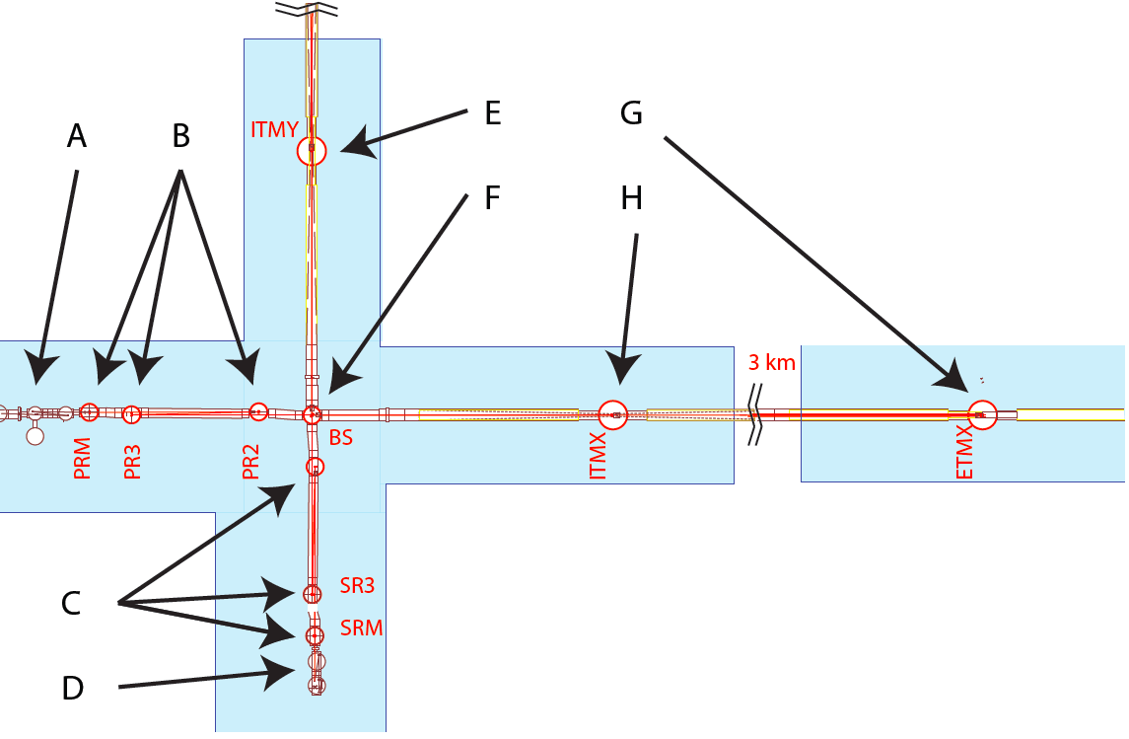
Figure 1: Layout of the KAGRA suspended mirrors and seismic attenuation system. A: input optics, B: type-B SAS for power recycling telescope mirrors, C: type-B SAS for signal recycling telescope mirrors, D: signal detection optics, E: Type-A SAS for cryogenic Inner Test Mass, F: Type-B SAS for beam splitter, G: Type-A SAS for cryogenic End Test Mass X (ETMY out of two shown), Type-A SAS for cryogenic Inner Test Mass.
The 13 m tall seismic attenuation chains isolating the four main cryogenic mirrors of KAGRA are called type-A. Each extends between two superimposed tunnels and is composed by a pre-isolator, three standard filters, and a control filter supporting the optical payload, which provide the dynamic controls needed to acquire lock. They are illustrated in figure “Type-A seismic attenuation chain”.
The 3 m tall seismic attenuation chains suspending the beam splitter mirror and the six recycler mirrors (three for the power recycler arm, and three for the signal recycler arm) are called type-B and comprise only one standard filter (instead of three), matching the less stringent isolation requirements. Apart from the number of filters and length, they are topologically identical and functionally similar to the type-A chains. They are illustrated in figure “Type-B seismic attenuation chain”.

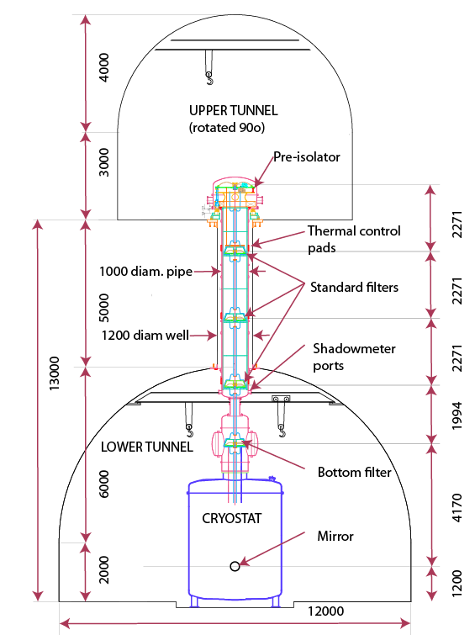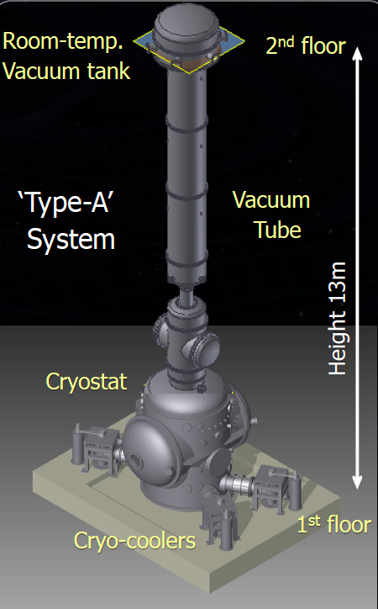
Figure 2 Type-A seismic attenuation chain for the cryogenic mirror suspensions. It is suspended from an upper tunnel (for convenience rotated 90o in this sketch). It is housed in a 1.2 m diameter well containing a 1 m diameter vertical vacuum pipe. The cryogenic payload, which is still in the design phase, is not shown.

The components of the attenuation chains of both types are common.
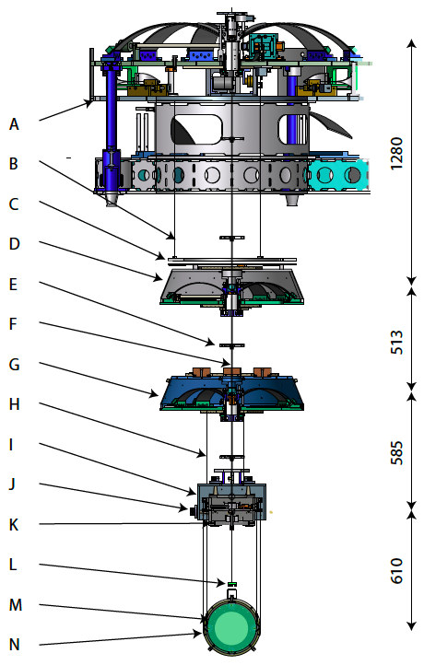
Figure 3: Type-B seismic attenuation chain used for beam splitter, power recycler and signal recycler mirrors. A: Pre-Isolator, B: Magnetic damper wire (3 of), C: Magnetic damper disk, D: Standard filter, E: cabling spider (1 or 2 per suspension wire), F: Suspension wire (3 along the chain), G: Bottom filter, H:

2. Underground environment and seismic suspension
As seen in figure 1, as tall seismic attenuators have to be instaled, the underground infrastructure has to be designed in smart way. Althought it might seem marginal, the definition of the underground environment, devoted to host a mechanical attenuator designed to isolate from seismic distrubance the payloads, is a crucial preliminary step leading to a clear desciption of the main characteristics of the suspension system. Once explained, the experience matured through the implementation of other key experiments, as Virgo, will easily drive to the complete study of KAGRA, the first large-scale interferometer installed in underground environment.

2.1 Tilt of the tunnel hosting the interfermeter
By far the most daunting feature of KAGRA’s site is the 0.3% inclination of its tunnels. Vertical springs have orders of magnitude more dissipation than horizontal pendulums, and more thermal noise. Because of the inclined beams, 0.3% of the vertical thermal noise of the lowest spring will couple directly into the interferometer noise budget, unless we find a way to filter it out by an extremely low-loss vertical compliance. The vertical spring thermal noise contribution can easily dominate over the thermal noise of the pendulum mode. Failure of properly addressing this problem will completely negate all advantages of cryogenic suspensions.
The inclined tunnel is a peculiar characteristic of KAGRA, imposed only by local rules related to the presence of heavy-metal-contaminated water in the Kamioka mountain. Tunnels, even longer ones like the tunnel under the British channel, are routinely made horizontal elsewhere. However, Earth’s is not flat, and a horizontal tunnel follows Earth’s surface curvature, while light beams travel in straight line. Therefore, even splitting the difference, i.e. accepting the opposite deviation from verticality at both ends, Earth’s curvature imposes a deviation from verticality of ~ 10-4 per km at the end of a long beam-line. Therefore in a detector with 10 km long arms like ET, the end stations will unavoidably be “tilted” away from horizontality by ~ 10-3 radians, which is about 1/3 of KAGRA’s slope.
To mitigate the vertical thermal noise problem, KAGRA’s final mirror suspension stage must include low-mechanical-dissipation vertical springs, an engineering requirement which is much more difficult to satisfy than building the cryogenic suspension wires. KAGRA is subject to about ten times more slope than if it was “horizontal”. Therefore it needs ten times more suppression of vertical thermal noise, which means it requires ten times softer final suspension springs.
Because the vertical springs pack a large amount of stress and energy, they end up being extremely fragile and dangerous. Sufficiently low vertical thermal noise is an extremely difficult one to achieve, requiring a very innovative composite suspension design. While no feasible solution is presently at hand, a few options are being investigated, and a possible design will be shown in [chapter xx].
Any solution devised to mitigate the vertical noise percolation into the KAGRA interferometer will be directly applicable to the suspensions of third generation gravitational wave detectors. On the other hand, third generation observatories will aim to Gravitational Wave detection at ten times lower frequency, therefore requiring low-noise springs operating at one order of magnitude lower frequency. This means these new detectors will need another factor of ten softer springs than in KAGRA. This is an extraordinarily stringent requirement, which most likely will be a limiting factor. It is vital, to minimize the problem, that third generation interferometers be designed with “horizontal” tunnels.

2.2 Solid footing of the attenuation chain head.
Experience in both LIGO and Virgo show that good footing of the seismic attenuation is of paramount importance. For example the “piers” supporting the LIGO seismic isolators produce a seismic perturbation amplification of at least an order of magnitude, a handicap that caused very poor duty cycle performance in initial LIGO and that still represents a performance limitation for the aLIGO active seismic attenuation system.
The massive superattenuator footings in Virgo were only partially successful in mitigating seismic noise amplification. Good isolator footing requires as short and as rigid connection to the bedrock as possible. Unfortunately KAGRA’s bulky cryostats do not allow a solid footing for the seismic isolators in the main experimental hall.

2.3 Tall structure safety considerations
A serious safety concern was encountered while building and maintaining the Virgo superattenuators because of their height. Working on such tall structures entails serious danger of falling or dropping tools, and required the addition of large scaffolding that encumber the space around the superattenuators, and can induce extra mechanical noise.

2.4 Instrumentation noise confinement.
In present observatories the majority of the mechanical noise introduced by human activities is due by the instrumentation operation noise of the electronics, air conditioning, pumping and other facility noises. Yet in an external building the instrumentation noise can radiate freely and dissipate rapidly. In a tunnel all this noise is bottled-in and reverberates with likely noise amplification effects. It is a serious problem; the pulse-tube cryo-chiller noise is of particular concern. CLIO, the cryogenic prototype of KAGRA, could not acquire lock unless the chillers were switched off. Although newer chillers are less noisy, chillers remain a serious concern. Electrical power line noise is also a concern, as substantial power is consumed in close confines.

2.5 Ventilation noise.
In a tunnel a vigorous air flow must be continuously maintained to remove rock heat, waste heat from instrumentation and machinery possible gas exhalations from the rock, and to renew air. Air flow is a known generator of acoustic noise in tunnels. Besides white noise, often organ pipe resonances are excited. In addition tunnels, especially straight ones, act as sound-guides, carrying machinery’s noise over very long distance, and buffering with walls and doors is often limited by the necessity of maintaining the air flow. Finally the vacuum works couple very effectively with any channeled acoustic noise.

2.6 The double tunnel configuration.
The solution devised to solve the last four problems in KAGRA is the double tunnel configuration illustrated in figure “Type-A seismic attenuation chain”. The head of the isolator chain is solidly footed on the rock floor of a short auxiliary tunnel, crossing the main tunnel at a higher level, directly above the interferometer test mass locations. The auxiliary tunnels are much quieter than the main tunnel because they are dead-end tunnels, accessible through a twisting ramp that can be closed off with doors. The attenuation chain hangs down through a small-diameter vertical well connecting the two tunnels. The vacuum pipe housing the attenuation chain also hangs down in the well from the top tunnel, it is connected to the top flange of the cryostat in the lower tunnel through a bellow that decouple mechanical vibrations. The empty space between the vacuum pipe and the well walls is buffered with light foam to keep the well from acting as sound guides. The footings of the attenuation chains are further decoupled from any possible vacuum tank vibration by bellows. This solution effectively mitigates any vibration of the cryogenic pumps, instrumentation and ventilation because the suspension are completely separated from the vacuum tube and all connections to ground are to the solid rock floor of a physically separated tunnel. Finally, the double tunnel solution has three additional advantages, biefly described as follows.

I) The required size of the halls housing the test masses is reduced by the double tunnel solution, therefore allowing reduction of the maximum transversal size of the hall and of the amount of excavation. Smaller excavation sizes reduce the surface stress on the rock and the required strength of the excavation’s lining. Having introduced less disturbances to the rock, one can expect a more stable hall, less prone to rock creep and/or cracking. The stability advantage also reflects on the excavation’s cost. The cost of an excavation grows faster than the cube of its smallest dimension. In KAGRA’s relatively small halls the cost of the two tunnels plus the cost of the access ramps were roughly equal to the cost of the larger cavern initially foreseen. Large cost advantages are expected for the case of third generation detector xylophones, which will require substantially larger spaces.

II) Separating the two tunnels by a larger distance, the length of suspension wire between attenuation filters can be made arbitrarily long. Longer wires lead to lower pendulum resonant frequency, a requirement for lower frequency gravitational wave detectors.
KAGRA did not directly use this advantage because the 5 m minimal separation between tunnels dictated by the local rock strength already lead to suspension wires longer than necessary. Having available more height than strictly necessary was useful in KAGRA, to implement a modified filter immediately below the attenuation chain head, whose main function is to damp the chain’s internal modes and make lock acquisition easier.
Given Virgo experience, the chosen configuration will assuredly deliver the attenuation required by KAGRA with a large safety factor. The low frequency detector of ET’s xylophone will require longer wires between filters. Wires of arbitrary length can be trivially implemented by increasing the separation between the upper and lower tunnel, and of the connecting well.
Parallel tunnels closer than one diameter are unstable. Therefore to minimize the vertical separation the upper tunnel was excavated at 90 degrees with respect to the main tunnel. (lower tunnel 12 m, upper tunnel 8 m, separation 5 m, see figure “Type- A seismic attenuation” and figure “Structure of the KAGRA tunnels”). As soon as the vertical separation exceeds the tunnel diameters, parallel tunnels can be excavated. This will be useful in third generation gravitational wave facilities where each tunnel will house multiple beams, each with Fabry-Perot mirrors at different locations along the tunnel. In KAGRA, due to the short length required (5 m) the seismic isolation wells were simply blasted with dynamite. The much longer wells needed for third generation gravitational wave detectors can be cheaply and safely excavated in hard rock with the raise boring technique (see tunnel chapter).

III) The attenuation chain can be easily and safely installed by lowering it in the well from the top tunnel. An important consideration in designing smaller size vacuum chambers is that also smaller diameter access tunnels or wells will be allowable and tunnel’like experimental halls becomes feasible. This is not a negligible cost; because of safety considerations each experimental hall will need its own access. In a fixed budget scenario, smaller volume excavation for access and experimental halls can be traded for longer tunnels, which directly increase the observatory sensitivity to gravitational waves.

In addition, if tunnel-like experimental halls with same, or only slightly larger, diameter than the long tunnels can be used, deeper facilities become feasible practically at no extra cost. While Raleigh waves and other perturbations radiating from the surface becomes only slowly weaker with depth even a small gain in low frequency sensitivity due to lower Newtonian noise translates immediately in increasing by a corresponding the highest mass of detectable black holes, a non negligible astrophysics advantage.

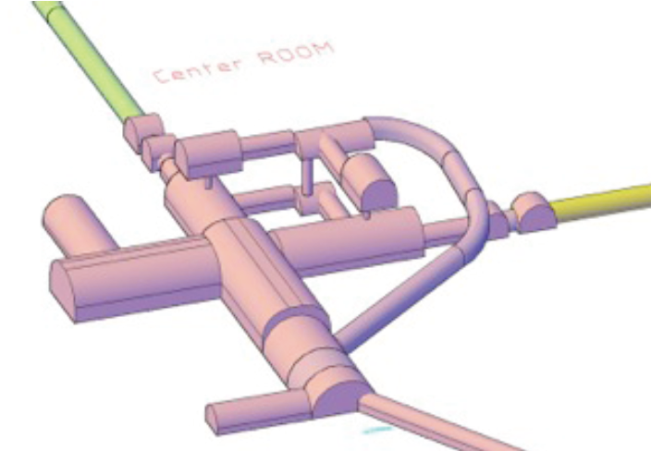
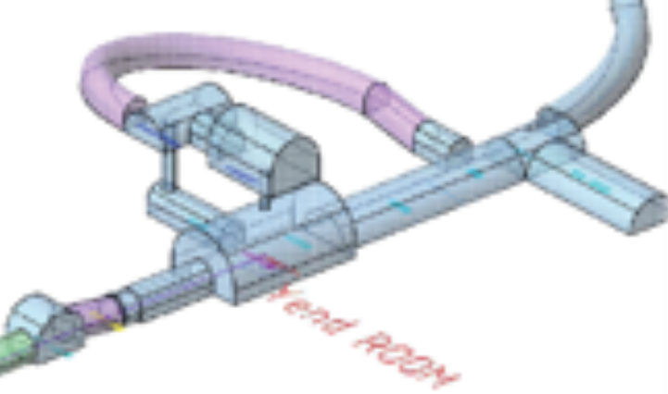

Figure 4: Structure of the KAGRA tunnels around the beam splitter (left) and one of the End Test Masses (right). The inclined ramps connect the main tunnel level with the auxiliary rooms housing the head of the type-A attenuation chains, 13 m higher.

2.7 Raise-Boring
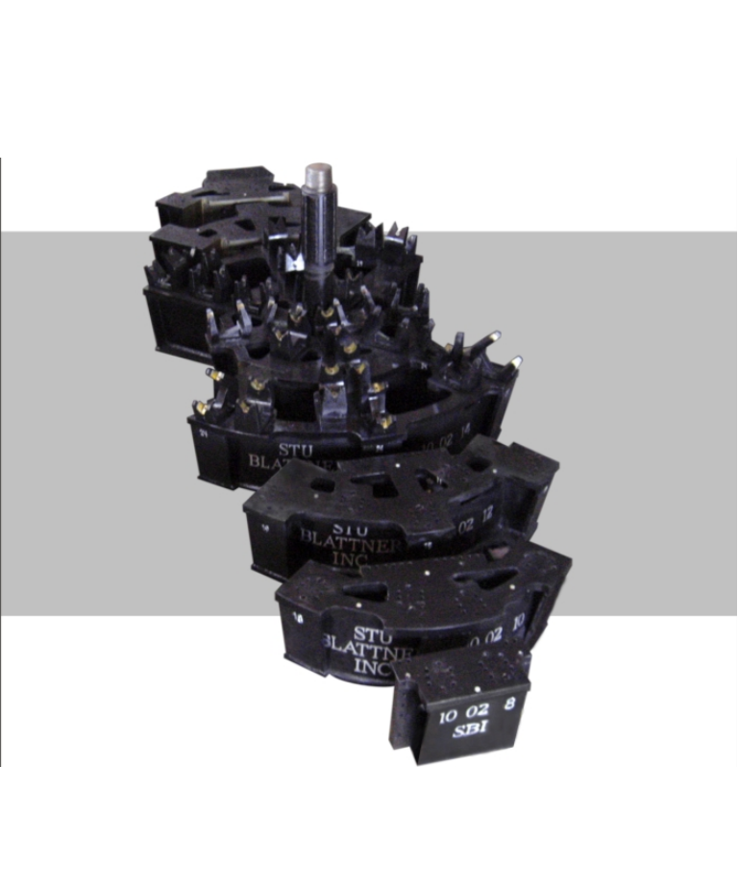
Raise boring (see figure “Raise bore head“) is a well digging technique used to build wells when the lower part can be accessed, to remove excavation debris. First a bore- hole is drilled from above and then it is widened to the desired diameter from below by means of a grinding head attached to the boring shaft. This technique can be used with small diameter heads (1. To 1.5 m) to dig between two vertically separated tunnels for the seismic attenuation chains, with intermediate diameter heads (~2. m) for escape routes along and at the end point of tunnels, as required by local legal requirements, and with large diameter heads ~3. m) to make access wells at the end stations.

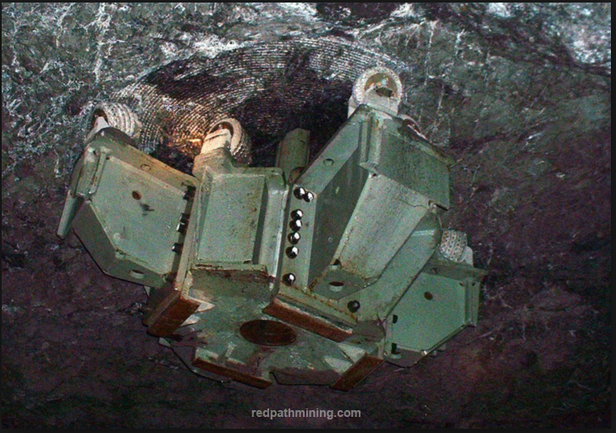

Figure 5: left, aise bore head staring to grinrid the well on the tunnel ceiling; right, 3 m diameter raise-bore head

3 The room-temperature seismic suspension for KAGRA; main charactersics
Considering figures 2 and 3, in this section the technical design of the main characteristics implemented in KAGRA seismic suspension will be motivated and described. As a foreword we resume the nominal achievement of KAGRA passive attenuator for seismic isolation (with room temperature payload) in comparison to the that of Virgo and ALIGO, whose nominal curve of attenuation is achieved through active control.

Figure 6: left, Attenuation chieved by means of Virgo "superattenuator" system as experimentally verified [Braccini et. al., AP. Ph. 23, 6, 557 2005] compard with nominal KAGRA and ALIGO (active system HEPI-BSC/ISI-QUAD).

3.1 Pre-isolators

The SAS pre isolator is composed by:
- an inverted pendulum table [-] [chapter #] and
- a large-diameter, low-frequency, vertical filter whose resonant frequency is lowered by the Geometric Anti Spring technique [] [chapter #].

The KAGRA pre-isolator inverted pendulums are virtually identical to the optical tables of the Albert Einstein Institute ten-meter prototype (AEI-SAS) [ ] and the NIKHEF Virgo injection bench (NIKHEF-SAS). The AEI and NIKHEF systems have three filters supporting optical benches from below, while KAGRA has a single, larger, but otherwise identical filter suspending the isolation chains from above. The pre-isolator covers the same functions of the three-stage active isolation of Advanced LIGO (which include one external hydraulic stage and two in-vacuum voice coil actuated stages). The KAGRA pre-isolator, like its German and Dutch brethren, is directly derived from the successfully prototyped, but never implemented, LIGO HAM-SAS [].
The performance of the pre-isolators in fully passive mode compares favorably with that of the three-stage aLIGO active attenuation system []. If installed in the quieter Kamioka tunnel environment the KAGRA pre-isolator would outperform the aLIGO system at all frequencies. For a fair comparison the measured transfer function of an inverted pendulum has been convoluted with a typical Hanford seismic activity in figure “Comparison between the measured performance”.
In addition, the IP pre-isolators have been engineered to support active attenuation in an ideal mode, mitigating the limitations imposed by the principle of equivalence to the aLIGO design []. The equivalence principle imposes that any horizontal accelerometer is also sensitive to a fraction of Earth’s gravitational acceleration coupled in by tilt noise. In absence of a suitable tiltmeter in parallel to each of its horizontal inertial sensors, an active attenuation is fooled by the seismic tilt noise into shaking the system at low frequency. To mitigate the influence of the equivalence principle, the horizontal isolation functions in KAGRA are provided by an Inverted Pendulum table, which is rigid in tilt. The horizontal attenuation function is thus completely separated from the vertical isolation functions, which is provided by a large GAS filter. This design was first developed for Virgo and TAMA and then perfected in HAM-SAS. The Inverted Pendulum is not immune from the principle of equivalence. It is equivalent to the test mass of an inertial sensor, therefore as sensitive to tilt just as the inertial sensors used in feedback in the active system. Only the use of a suitably sensitive tiltmeter would allow complete elimination of the equivalence principle limitations. The inverted Pendulum gives to the SAS pre-isolators the potential of actively augmenting the attenuation performance to the limit of present and future inertial sensors while avoiding the limitations imposed by the principle of equivalence on six degree of freedom suspensions (which include tilts), further exacerbated by the response of the internally suspended masses like in aLIGO [].
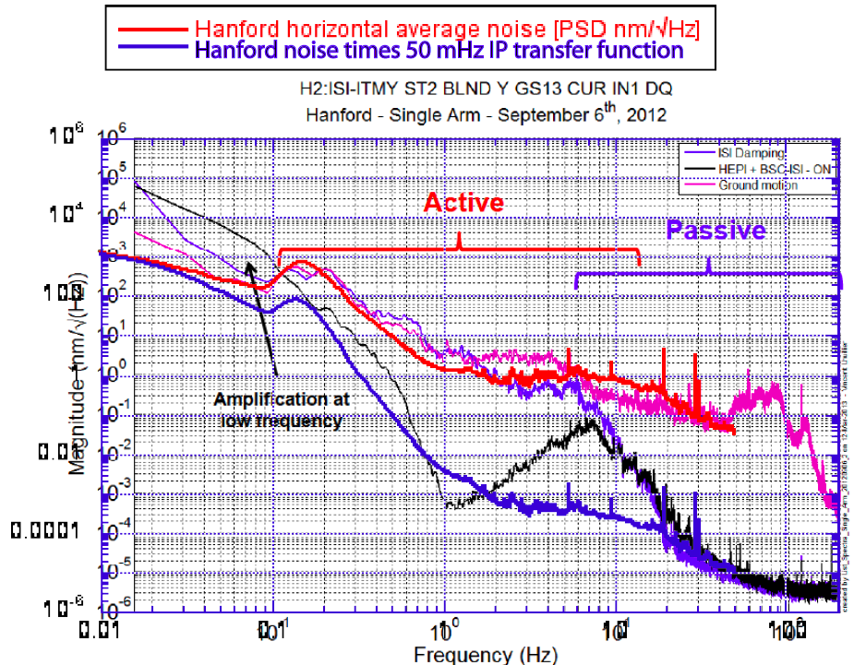
Figure 3: Comparison between the measured performance of the three-stage Advanced LIGO seismic attenuator at Hanford and the predicted performance at the same site obtained multiplying the Hanford seismic noise by the Inverted pendulum table transfer function in fully passive mode, with the tuning parameters of 50 mHz and a 70 dB center of percussion tuning achieved in AEI [].
It should to be noted that presently available inertial sensors have sensitivity that is only marginally better than the underground seismic activity. Therefore, except for inertial modal damping, there is marginal advantage in using them for active isolation underground. However the SAS pre-isolators are engineered to easily profit from advanced sensors, whenever a suitably sensitive one would become available. As will be discussed below, the SAS pre-isolators will have sufficient performance for KAGRA, while some advances may be needed to push the sensitivity of third generation interferometers to very low frequency.

3.2 The height problem.
The Virgo inverted pendulums were 7 meter tall. The main reason to make them so tall was to gain the height necessary to suspend the rest of the superattenuator chains. Similarly in TAMA the inverted pendulums were 1.8 m tall. In both cases the most serious problem was due to the large mass of the Inverted Pendulum legs inducing saturation of the attenuation performance. A careful counterweighting of the legs was necessary to null the center of percussion problem. All subsequent inverted pendulum designs were made with much lighter, 0.5 m long legs. The lighter legs were capable of the same attenuation performance while attenuation saturation was much reduced. Careful counterweighting of these lighter legs produced horizontal attenuation as large as 90 dB.
Because KAGRA’s pre-isolators are identical to those implemented in the LIGO HAM-SAS, AEI-SAS and NIKHEF-SAS, they will use standard control programs [chapter #] being developed and honed in NIKHEF and AEI, and incorporate all improvements developed there.

3.3 The main attenuation chain.
The KAGRA attenuation chains use filters derived from TAMA-SAS [], using the same cantilever blade design. The vertical attenuation filters operate at low frequency thanks to the Geometric Anti Spring configuration. That filter design was further improved at LIGO with the implementation of center of percussion compensators [] also used in the AEI and NIKHEF SAS. In KAGRA the vertical filters exist in two sizes, a larger version used in the pre-isolators, and a smaller version, used in the standard filters and in the bottom filters.
The Standard filters are used in the long attenuation chains isolating the four GW test mass mirrors [chapter # type-A], as well as in the shorter chains supporting the beam splitter and recycling mirrors [chapter # type-B]. These filters are virtually the same used in the AEI and NIKHEF filters.

3.3 Improvements with respect to Virgo superattenuator scheme
KAGRA’s attenuation chains represent a vast improvement with respect to Virgo’s superattenuators because they incorporate passive damping of the chain’s modes.

3.3.1 Increasing the frequency and damping the yaw and violin modes.
The Virgo superattenuator scheme worked extremely well and delivered more than the required attenuation[] but were difficult to implement. The most serious implementation problem was due to the r.m.s. motion of the chain yaw resonant modes, which were at very low frequency and presented very high quality factor. These modes were easily excited to excessive amplitudes, extremely long lived and very difficult to damp. This problem greatly delayed the achievement of fast and reliable locking in Virgo and an external damping scheme had to be retrofitted. A two-step method was engineered ab-initio in the KAGRA seismic isolation to solve this problem. A redesign of the suspension wires increased the resonant frequency of the yaw modes. An Eddy current damping stage placed between the pre isolator and the top stage of the chain was added to damp the yaw mode without introducing noise in the lower stages. As an added benefit, the chain’s “violin” modes were effectively Eddy current damped as well.

3.3.2 Damping the main pendulum mode.
The main pendulum mode can also get easily excited to excursions exceeding the authority of the mirror-control low-noise actuators. This high quality factor mode also contributed stretching the lock acquisition time in Virgo. This problem was mitigated with inertial damping, i.e. horizontal inertial sensors at the head of the chain sense the chain oscillation recoil and provide damping feedback. Because of the lower-frequency pendulum resonance of the longer chains in KAGRA, the inertial sensors will be less effective for damping. The main pendulum mode can be sensed in two modes. A rock-based shadow-meters that will be reading the position of the suspension wire six meter below the pre isolator. The mirror optical lever beam can be used, in fringe counting mode, to read the position of the main mirror. Both signals, combined with the inverted pendulum position sensor signals, provide an effective active damping signal of the pendulum mode. The requirement is to bring the pendulum oscillation amplitude below a fraction of µm for lock acquisition. After lock is acquired, the main interferometer length-sensing signal would kick in as feedback signal.
With the improved yaw and pendulum damping, KAGRA is expected to easily and promptly acquire lock, with reduced lock acquisition forces. Inertial damping may be simplified or eliminated. This damping approach is expected become progressively more effective at the lower frequencies required by the third generation GW detectors.

3.3.3 Interferometer lock acquisition and control forces
In order to maintain interferometer lock, the mirrors need to be positioned at a suitable interference length within a range that is a small fraction of the light wavelength divided by the effective finesse of the cavity. This allowable range is typically of the order of 10⁻¹² m below the frequency region of Gravitational Wave detection (i.e. below 10 Hz). Any deviation from the resonance point larger than that would result in lock loss. The allowable alignment error during lock acquisition is of the order of a micro radian. The radiation pressure during interferometer operation is of the order of the milli-Newton for KAGRA, and can be several times larger in interferometers with higher stored power. During the lock acquisition process the stored optical power ramps up in microseconds. The ramping radiation pressure, if not neutralized, would cause the suspended mirror to recoil by several microns, million of times more than the allowable range. The mirror actuators must therefore be able to overwhelm, in real time, the rapidly changing radiation pressure during lock acquisition. Electromagnetic actuators with the authority of few mN are necessary, unless a slow and gradual power buildup is achieved by other means.
To maintain lock and detect gravitational waves, the mirrors need to stay in the lock position within the same precision with actuation forces negligible with respect to the action applied by an incoming gravitational wave, i.e. 10⁻²⁰ m/√Hz above 10 Hz in the advanced detectors. The electrical noise of actuators with the authority of few mN would inevitably cause mechanical noise well in excess of 10⁻²⁰ m/√Hz. To solve this conundrum, one takes advantage of the fact that, after lock acquisition, the radiation pressure is a standing force, which can be offset by simply moving the suspension chain head forward by an appropriate amount and let the suspension wires lean against the radiation pressure. After lock is acquired, the standing force required from the actuators can be nulled by a suitable advance of the suspension point. As soon as the standing force of the mirror actuators is nulled, they can be switched off, or to a low-authority, low-noise mode, and the Gravitational Wave detector reaches its observation mode.

3.3.4 Advantages of applying controls from the intermediate mass
The position authority of an actuator of a given force is a function of frequency. The acceleration imparted by an actuator to a suspended body is given by the applied force divided by the mass it pushes against. The maximum displacement at high frequency is:
where M is the mass of the body and F_{max} is the maximum force of the actuator:
for the maximum applied voltage V_{max} with K_{electrical} a constant depending on the actuator characteristics. The actuation noise is equal to:
where is the electronics noise.
Therefore at high frequency the position authority and the actuation noise decrease rapidly, while at low frequency the position authority increases until the suspension resonant frequency is reached.
Below the suspension resonant frequency the position authority saturates at the value:
Where l_{pend} is the suspension length.
Requiring an authority of the order of several µm at low frequency would generate an actuation position noise well in excess of 10⁻²⁰ m.
While actuators are needed to acquire lock, for noise reduction-sake, after acquisition it is extremely advantageous to apply indirectly all forces necessary to maintain the interferometer in lock. This can be done applying appropriate forces on the intermediate mass above, thus controlling the mirror like a marionette.

The low frequency actuation authority on the mirror is the same of the actuation authority on the intermediate mass because the mirror is dragged along by the intermediate mass:
where l_{int} is the pendulum length suspending the intermediate mass and M_{tot} is the sum of the masses of the mirror, intermediate mass and mirror recoil mass.
The high frequency actuation noise is then:
where M_{int} is the intermediate mass and is the pendulum resonant frequency of the mirror.
In addition, whilst in lock the F_{max} required on the intermediate mass is orders of magnitude less than the F_{max} required on the mirror to acquire lock. Therefore the F_{noise} on the intermediate mass will also be much less than on the mirror itself during lock acquisition.
When the mirror controls are switched off, and the control forces necessary to maintain lock are applied from the intermediate mass, these two advantageous factors are combined, and it becomes relatively simple to maintain the mirror actuation noise below the required 10⁻²⁰ m/√Hz in the Gravitational Wave detection bandwidth. These low control noise techniques have been pioneered and largely tested by Virgo [ - - ].

3.3.5 Alignment
Similarly the mirrors need to be aligned to acquire and then to maintain the interferometer lock. The angular alignment and the damping for lock acquisition can suitably be provided by optical levers. During interferometer operation the alignment signal is given by wave-front sensing. As in Virgo, the same actuators, applying forces within the suspension system at the level of the payload can be used. DC components of the force will be minimized by using static balancing of the intermediate mass that supports the mirror. The accuracy of such a positioning should be of the order of 1 urad, in order to keep low the DC voltage on intermediate mass actuators, but the range of the slider should be large enough to cover the tunnel tilt (0.3 %), hence a mass of about 1 kg should be used.

Hopefully all the internal modes of KAGRA payload will lay within few Hz. The study of the controllability of the system withing a given bandwidth and aimed to minimize the technical control reinjection in the detection bandwidth of KAGRA is a matter closely related to the payload design and then still unfrosen at the level of this report.

3.3.6 Forces and noise issues on the beam splitter and recycler mirror suspensions
The suspension noise requirements of the warm mirrors of KAGRA are not as stringent as those of the four Gravitational Wave test masses. These requirements are reduced by the finesse of the Fabry-Perot cavities and by the common noise rejection of the beam splitter. Although less stringent, and well above the thermal noise limitations of room temperature mirrors, these noise requirements are still tight. Marionetta-type controls with metal wire suspensions have been successfully developed and extensively tested in initial Virgo. Therefore the design of the suspensions of the warm mirrors in the Type-B chains is essentially borrowed directly from initial Virgo’s.
While KAGRA adopted Virgo’s marionette control scheme, the Optical Sensor, Electro Magnetic Actuators, known as OSEM were incorporated in the design to simplify operations. These sensor-actuators were successful tested in LIGO and are being implemented in aLIGO to damp the internal modes of the suspension and to apply the actuation forces on the mirrors.

3.4 Type-B Seismic Attenuation and mirror suspension chains

Type-A (cryogenic) and type-B attenuation chains use the same components and have similar topology. We analyze first the detailed structure of type-B chains including the warm (type-B) suspensions, with the understanding that the cryogenic suspensions use different materials but will have similar topology and functionalities.

3.4.1 Isolation and control scheme topology and functionalities.

The isolation chain topology was already illustrated in figure “Type-B seismic attenuation chain” and figure “Type-A seismic attenuation chain”.
Each component of the attenuation chain has specific functions, in certain cases hierarchically overlapping. We remind that the mirror actuator authority must be minimized because their force noise is proportional to the electronics noise, and large control authority would produce control noise overwhelming the gravitational wave signal. Besides attenuating mechanical noise in the gravitational wave detection band, the most important function of the chain is to reduce the low frequency r.m.s. motion of the mirror well below the range that can be handled within the authority of the mirror control actuators. This second function is shared by several components along the chain.
- The pre-isolator has the following functions:
- Provide sufficient low frequency isolation at the micro-seismic frequency level to reduce the r.m.s. motion of the mirror in that frequency range.
- Actively or passively damp any attenuation chain resonance that could be excited with amplitude exceeding the mirror control authority.
- Micro-position the attenuation chain head and the mirror in the longitudinal, transversal, vertical and in yaw degrees of freedom.
- Provide a share of seismic the attenuation in the interferometer GW detection band (above 10 Hz).
- Provide a diagnostic and calibration tool to ensure the performance of the rest of the chain.
- The standard filters are designed to provide the bulk of the attenuation in the GW detection frequency band. The vertical attenuation is obtained through cantilever springs and the horizontal attenuation as a chain of simple pendulums.
- The Eddy current damping ring is primarily designed to damp the yaw motion of the attenuation chain. It is a key element to reduce the yaw r.m.s. motion and therefore the authority demanded on the mirror actuators. As an added benefit it damps also the “violin modes” of the attenuation chain, and to some level its pendulum mode. It thus reduces the r.m.s. motion of the mirror in the intermediate frequency range (from a fraction to a few Hz).
- In the type-A attenuation chains, a shadowmeter placed below the last standard filter has the function to provide a feedback signal to the pre-isolator horizontal actuators to damp the pendulum mode of the chain thus reducing the r.m.s. motion of the mirror at the lowest frequencies. In conjunction with the inverted pendulum position sensors, it provides a means of monitoring seismic tilt motion of ground.
- The bottom filter has the functions of providing:
- independent suspension of the intermediate mass and the intermediate-mass recoil mass
- fine pitch, yaw and vertical relative positioning of the intermediate mass recoil mass with respect to the intermediate mass
- additional attenuation in the GW detection frequency band.
- The intermediate mass functions are to provide:
- independent suspension of the mirror and the mirror recoil mass
- static pitch positioning of the mirror
- The intermediate-mass recoil-mass functions are:
- to carry the dynamic actuators and position sensor acting on the intermediate mass
- to provide dynamic control forces on the intermediate mass in all six degrees of freedom by means of strong OSEMs to reduce the control authority required from the mirror position actuators below the limits imposed by their required noise level.
- The mirror recoil mass functions are:
- to carry the dynamic actuators and position sensor acting on the mirror
- to provide dynamic interferometer lock control forces on the intermediate mass in the longitudinal, pitch and yaw degrees of freedom by means of low-force, low-noise OSEMs
The static positioning in all five degrees of freedom (excluding mirror roll) are designed with remotely controlled mechanical settings to be only occasionally changed to allow all dynamic actuators to work around a null static force.

3.4.2 Horizontal Pre-isolation (inverted pendulum)
The horizontal attenuation of the KAGRA pre-isolator illustrated in figure “Schematic view of the inverted pendulum”, is provided by an inverted pendulum table composed by three legs, 440 mm long, 48 mm diameter, 1 mm thick, 180 g mass distributed on a 1236 mm diameter circle, supporting a 1340 mm diameter steel disk forming the table and the base of the vertical pre-isolator GAS filter. The mass of the pre-isolator filter is more than 300 kg, depending on required load. The mass of the leg is kept low so that, without counterweights, the attenuation limitation engendered by the center of percussion effect is already below 60 dB. A counterweight bell is foreseen as well to move the center of percussion to the pivot point on top of the leg and push the attenuation plateau below 80 dB.
The inverted pendulum legs are provided with counterweight bells that can be loaded with tuning masses to tune the position of the center of percussion. Wanner in his thesis reports an overcompensation with the bell still unloaded and a 70 dB attenuation plateau. To reach better compensation either lighter bells or heavier legs. To address this problem, and to increase the bounce mode frequency of the optical bench above, NIKHEF-SAS was built with heavier stainless steel legs, which are still being tested. The improvement will then be transferred to the KAGRA design. Wanner estimates that attenuation plateaus as low as 110 dB may be possible.
The inverted pendulum restoring force is provided by a stiff lower flexure, 60 mm long. The diameter of the three flexures is calibrated to produce a restoring force
K_{el} = Eπd⁴/(L_{f} 64)
Where E = 186 GPa the Young’s modulus of maraging [Braccini 2000], L_{f} and d the length and the diameter of the flexure, balancing the gravitational negative stiffness of the inverted pendulum
K_{grav} ~-Mg/3L
where M is the overall load (including the weights of the pre-isolator, all the isolation chain that it suspends, and its damping system), g if the gravitational constant and L the effective length of the leg.
The top flexure is thin and soft, it contributes negligibly to the restoring force. The
NIKHEF’s Multi-SAS is built slightly differently, with equal flexures, each with half strength, on both ends of stiffer steel legs. This variant changes little to the Inverted pendulum operation mode, but raises the bounce mode frequency of the table discussed below.
The inverted pendulum resonant frequency is finely tuned by the addition of tuning masses. Resonant frequencies of 30-50 mHz have been achieved in inverted pendulum tables of this kind at NIKHEF and AEI while lower frequencies were obtained in taller systems [-]. Lower resonant frequencies are expected to be achievable in vacuum and with advanced leveling systems described in chapter “Supporting and balancing the Inverted pendulums”. The lowest limit of the inverted pendulum operational resonant frequency is set by the low frequency instabilities of the Young’s modulus in the flexures, due to collective dislocation activity[].
The Inverted pendulum legs have internal resonances around 100 Hz that are very effectively damped by Eddy current dampers mounted around the leg’s head [, ].

3.4.3 Functional differences between AEI, NIKHEF and KAGRA Inverted Pendulums.
The inverted pendulums of AEI and NIKHEF support an optical table, while KAGRA’s Inverted pendulums support only the pre-isolator filter with a payload supported centrally by a wire. The optical tables are strongly sensitive to tilt (pitch and roll) resonances. It was found that the longitudinal elastic constant of the legs, added to the elasticity of the thin top flexure of the Inverted Pendulum leg, caused unwanted pitch, roll and bounce resonances, quite difficult to damp. Where needed, inverted pendulums were re-designed with steel tubes and stronger top flexures to increase the vertical bounce frequencies. Then resonant dampers precisely tuned to these resonances were added on the tables to absorb any residual oscillation.

3.5 Inverted pendulums for the third generation detectors
Although no specific improvement may be required to satisfy the requirements of third generation gravitational wave interferometers, the inverted pendulums may profit from flexures made of lower hysteresis elastic materials. The hysteresis is associated with the fluctuations of the material’s Young’s modulus, which limit the inverted pendulums low frequency tune. Possible candidates are bulk glassy metals presently in a pre-industrial phase[]; prototype tests are needed to make sure that these materials have no unexpected counter-indications.
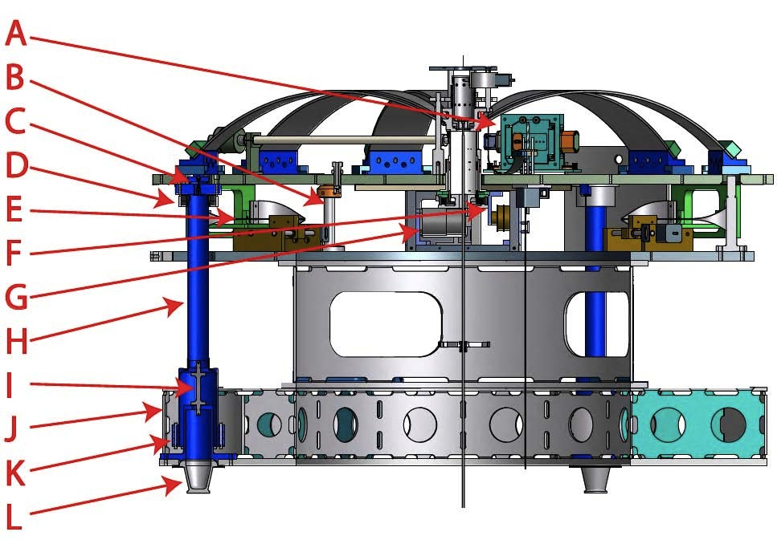
Figure 4. Schematic view of the inverted pendulum horizontal isolation table. A: horizontal accelerometer, B: movement range limiter column, C: top flexure (soft), D: Eddy current magnetic resonance damper, E: stepper-motor-actuated working point tuning spring, F: LVDT position sensor, G: voice-coil actuator, H: leg, I: bottom flexure (stiff), J: main support structure, K: leg counterweight, L: Through-vacuum supports. Due to the 120º symmetry, all parts except J are 1 of 3.

3.5.1 Supporting and balancing the Inverted pendulums
The inverted pendulum base structure needs to be precisely leveled. It is supported on three points by means of through-vacuum supports. These through-vacuum supports are mechanically separated from the vacuum tank by bellows, so that the vacuum tank vibrations are not transmitted to the attenuation chains. These three supports sit on precision mechanical pistons with a few micron precision, described in the “external support” section. They allow leveling of the inverted pendulum base structure parallel to the effective inverted pendulum horizon within a few parts per million. The effective horizon felt by the inverted pendulum is the setting at which the table sits centered with respect to its base. It may differ from the actual horizon because of small machining and assembly errors on the base and the flexures.
The residual transversal (X and Y) and angular (yaw) static adjustments of the inverted pendulum working point are applied by three stepper motor controlled tuning springs shown in figure “Stepper motor controlled springs for Inverted pendulum static positioning” placed at 120º on the outer diameter of the inverted pendulum table.
The position of the inverted pendulum table is monitored by three LVDT sensors [], placed opposite to the static springs. These LVDTs, shown in figure “Horizontal LVDT and Voice Coil Actuator”, have nanometer resolution and a few mm range. Dynamic control of the inverted pendulum table and tidal working point corrections are applied via constant force voice coil actuators [] collocated with the LVDT, also shown in figure “Horizontal LVDT and Voice Coil Actuator”.
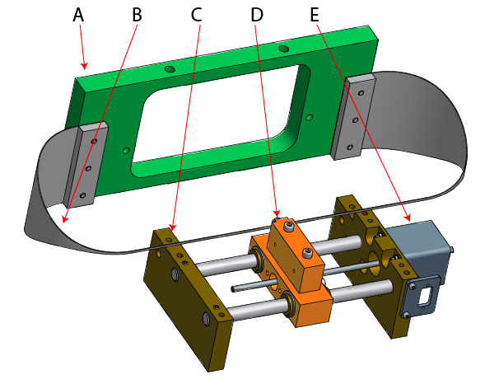
Figure 5: Stepper motor controlled springs for Inverted pendulum static positioning. A: Spring holder, on moving table, B: Blade springs, C: Stepper motor support and slider guide, on base structure, D: Slider, E: stepper motor with long threaded shaft.

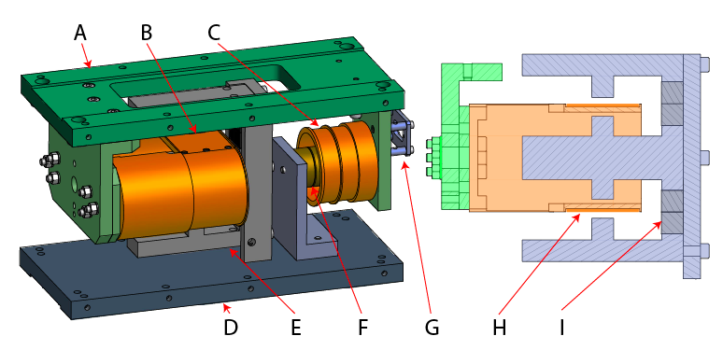
Figure 6: Horizontal LVDT and Voice Coil Actuator. Green and Orange: moving parts; gray and blue: static parts. A: Moving sensor-actuator plate, B: Actuator racetrack coil support, C: LVDT secondary support, D: Static sensor-actuator plate, E: Magnet Yoke, F: LVDT primary, G: cable connector, H Actuator winding, I actuator permanent magnets.

3.5.2 Inverted pendulum table inertial sensors
Space is foreseen on the KAGRA’s inverted pendulum table for implementation of uniaxial accelerometers [ ] or geophones [] for active seismic attenuation.
The inverted pendulum has a fundamental advantage. Once leveled, the inverted pendulum table is constrained to move in a fixed plane parallel to the horizon and it faithfully follow it in the two tilt degrees of freedom. The inverted pendulum plane is parallel to its base structure within an angular error
∆ø=∆x_{mech} D <0.1/1236 ~ 0.8 10⁻⁴
where ∆x_{mech} is the sum of machining and assembly errors D is the table diameter. Unequal length legs, or legs not mounted perfectly parallel to each other can generate some dynamically changing angle between the table and ground. The dynamic tilt variations induced by motion within the table’s range limits ∆ø_{dyn} are:
∆ø_{dyn} = ∆ø R / L_{leg} ~ 0.8 10⁻⁴ *5 / 600 ~<10^{-6.}
where R is the movement range (±5 mm) and L_{leg} the leg length (600 mm). These small deviations from planar movement are effectively negligible. The inverted pendulum table therefore copies ground tilt noise at all frequency below the bouncing modes of the legs.
It is well known that a horizontal accelerometer on the seat of an ideal swing is insensitive to the swing’s oscillations, independently from their amplitude, because the swing’s seat is subject only to the force of the rope that is perpendicular to the accelerometer’s sensitivity plane and therefore unable to generate a signal on the horizontal accelerometer. In those conditions the signal of the acceleration of gravity times the swing’s seat angle completely cancel the longitudinal acceleration. The principle of equivalence commands that only second order effects like can be felt.
The inverted pendulum can be seen as a platform sliding on a horizontal surface with no friction. Considering a horizontal accelerometer on such a platform.
- When subject to a floor tilt, the platform accelerates horizontally to cancel the fraction of Earths gravitational acceleration g projected on its plane, and the accelerometer reads nothing.
- If the ground accelerates horizontally, the platform remains inertial, and the accelerometer reads nothing.
The Principle of Equivalence dictates that an accelerometer mounted on an frictionless platform is completely ineffectual to mitigate the low frequency motion imparted by the ground seismic tilt noise.
Note: An accelerometer mounted on an inverted pendulum table remains effective for inertial damping because it can read the recoil forces from the oscillations of the chain attached to it, which are not subject to the limitations of the Principle of Equivalence.
If the platform movement is not completely frictionless, some ground floor movement is coupled in, and not all tilt signal is cancelled. The accelerometer signal is an indistinguishable mix of the two contributions, and is difficult to use.
Things become more complicated with a real life inverted pendulum table with a restoring force. Below the resonant frequency, say 30 mHz, the seismic movement is fully transmitted and readable by the accelerometer while seismic tilt produces a sliding motion of the table similar to that of a sliding platform, initially nulling the accelerometer’s signal. The tilt-induced sliding is limited by the restoring force, therefore the tilt induced accelerometer signal is generated with a delay.
Above the resonance the transmitted seismic motion phase rotates by 180º, and its amplitude falls off as 1/f². The tilt signal on the accelerometer is masked by the table’s sliding motion. Above the Inverted Pendulum resonant frequency, a sufficiently sensitive horizontal accelerometer will record the residual seismic motion noise not filtered by the Inverted Pendulum. Because the residual signal is weak, the accelerometer would be ineffective for active seismic attenuation, unless the accelerometer is built with a technology superior to that of the table.
Around and below the resonant frequency the movement and tilt signal are mixed and cannot be separated to generate an effective feedback signal. Only approximate tradeoff solutions, generating seismic noise mitigation of one kind at the cost of worsening the other problem, are possible.
An accelerometer placed on ground can be considered to generate a feed forward corrective force to mitigate the ill effects of tilt. The accelerometer test mass, which is as inertial as the Inverted Pendulum table, could be considered an ideal source for such correction force. Unfortunately, the accelerometer is intrinsically sensitive to both tilt and acceleration and would eliminate the effects of tilt at the cost of re-injecting some or all of the horizontal seismic noise that the Inverted pendulum has filtered out.
It is therefore clear that active attenuation with accelerometers alone cannot add much to an inverted pendulum performance.
It would be nice to insert here some more mathematical description here.
Tilt rigidity is also important when considering actuation and active seismic noise suppression. In absence of tilt rigidity, spurious tilt noise is generated by actuation forces not applied on the center of mass plane, by horizontal or vertical seismic noise in a platform that is not precisely suspended from its center of mass, and by movements of objects mounted on the platform itself. Neither actuation forces, nor movements of the payload, can cause spurious tilt on the inverted pendulum table and pollute the signal of on-board inertial sensors. Spurious tilt is the reason why the aLIGO active hydraulic isolation stage relies on feed forward from ground sensors with an optimized Wiener filter for low frequency active attenuation and low frequency feedback from on-board sensors was abandoned.
A separate advantage of the low frequency tuning of the inverted pendulum is that the very weak residual seismic noise forces injected on the table can be absorbed by weak actuators, which have correspondingly less actuation noise and less power dissipation. The inverted pendulum is therefore the ideal platform for active attenuation in the horizontal plane as discussed by Stochino et al. [].
The inverted pendulum is equivalent to the test mass of a horizontal inertial sensor and at low frequency coupling of tilt noise is unavoidable. Tuning the Inverted pendulum to very low frequency (50-30 mHz or lower) is advantageous because it generates attenuation at the microseismic peak, but that comes at the cost of allowing very low frequency tilt to cause larger movement. This is still an advantageous tradeoff because the seism is smaller below the microseismic peak, and because very slow movements do not impede lock acquisition and can be neutralized by feedback after the interferometer acquires lock.

3.5.3 Low frequency dominance of tilt in seismic noise.
The only way to avoid the limitations of the Principle of equivalence is to add the signal of a tiltmeter insensitive to horizontal acceleration. A pure tiltmeter, mounted on ground, or equivalently on the table, generates the ideal signal to mitigate the tilt-induced low-frequency motion of an Inverted pendulum table and opens the way to supplementary active attenuation.
Note : Tiltmeters of sufficient sensitivity were not available until recently[], for the same material property reasons that limit lower frequency tune of GAS filters and the Inverted Pendulum themselves. They became feasible only by eliminating or mitigating the fluctuations of equilibrium point of flexures generated by the collective activity of dislocations in metals [].
It should be noted that at low frequency the seismic perturbation is strongly dominated by tilt. Dergarchev tested a new, high sensitivity tiltmeter, insensitive to horizontal acceleration. To calibrate it he compared it with the signal of a collocated Trillium seismometer. He found that most of the horizontal accelerometer signal registered by the Trillium was compatible with tilt [], only a small fraction was true movement. Vajente observed that the Virgo inverted pendulum motion below its own resonance is dominated by tilt []. Matichard observed that below 200 mHz the Advanced LIGO active attenuators shake up the payload with an amplitude which is 100 times larger than the actual seismic noise [].
Only the concomitant use of a sufficiently sensitive tiltmeter, like the one developed by Dergarchev, can offset the limitations imposed by the principle of equivalence to active subtraction of seismic noise at low frequency. In KAGRA a shadowmeter measuring the suspension wire movement in the lower chamber was designed to measure the pendulum mode of the attenuation chain. Once the pendulum and violin modes of the chain are damped or subtracted, the shadowmeter signal becomes equivalent to the inverted pendulum position sensor signal for what regards actual horizontal motion, but not for tilt. The ground tilt signal can therefore be extracted from the difference of the two signals, thus generating a virtual low frequency tiltmeter. It turns out that the use of this composite signal is rather difficult.
In KAGRA the use of high sensitivity tilt meters in conjunction with seismometers or geophones can be considered as an optional. In third generation observatories tiltmeters will likely become a necessity.

3.5.4 Performance of the Inverted Pendulum

Since the IP legs of the horizontal attenuation system of the KAGRA pre-isolator are identical to the AEI-SAS IPs, the counterweight mass and the performance evaluation are the same as the AEI measurements. Those measurements are described in the [optical bench] chapter.
The performance illustrated in figure [Measured seismic noise at Kamioka] is calculated using the measured noise inside the Kamioka tunnels, assuming a minimal 50 mHz frequency tuning and 70 dB center of percussion tuning of the Inverted pendulum table.
Takanori, do you want to replace with other figure and expand?
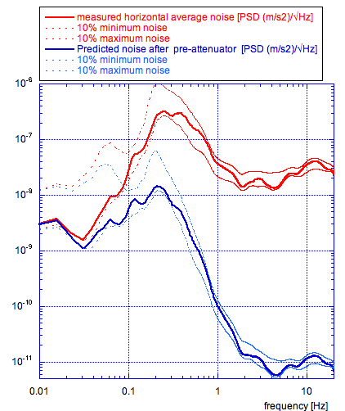
Figure 7: Measured seismic noise at Kamioka in red (source Somya), and predicted performance of pre-isolator with a tuning of the inverted pendulum at 50 mHz and legs counterweights tuned for a center of percussion depression to 3 10⁻⁴ as tuned in NIKHEF. The dotted lines are the maximum and minimum noise occurring 10% of the time during the measurement.

3.5.5 Vertical Pre-isolation filter.
The low frequency vertical pre-isolation, illustrated in figure “Top filter schematic view”, is provided by a large GAS filter, also known as top filter. It cannot match the frequency tune of an inverted pendulum, but it is tuned at the lowest possible frequency to start its 1/f² attenuation transfer function at the lowest possible frequency. The GAS filters are built with Maraging steel blades, one of the strongest, creep-free and most elastic (low loss) spring-steel available. Yet the elastic constant cancellation of the GAS configuration exposes even tiny deviations from elasticity of the material. The lowest achievable resonant frequency is thus limited by the Young’s modulus instabilities in the cantilever springs’ metal. This issue will be discussed in the sections “Controlling Self Organized Criticality instabilities” and “Setting the true equilibrium point at the desired working point”.
The top filter fulfills several functions besides providing low frequency vertical attenuation:
- Static micro-positions the attenuation chain in the vertical direction
- Sensing of the vertical working point and motion of the chain
- Static micro-positions the attenuation chain in the yaw degree of freedom
- Vertical dynamic actuation of the attenuation chain
- Provide a inertial vertical sensors platform for active attenuation, if needed
- Support the Eddy current damper for the first standard filter.

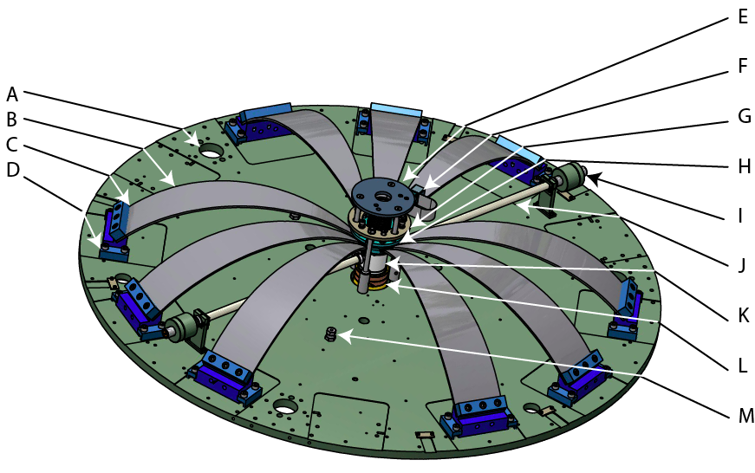
Figure 8: Top filter schematic view: A: Inverted pendulum socket, B: Blade (in multiples of 3), C: Blade’s base clamp, D: Sliding clamp for filter vertical resonant frequency tuning, E: Geophone platform (optional, moving with keystone), F: Stepper motor for suspension wire rotation, G Keystone range limiter plate (attached to base platform), H: keystone, I: Magic wand counterweight, J: Magic wand, K: LVDT primary and actuator coil column, L: LVDT secondary, M: attachment point for Eddy Current Damper suspension wire (one of three), N: Top filter base plate

Simple pendulum Horizontal isolation
Progressive horizontal attenuation is produced along the chain by the multiple pendulum effect of a number of masses separated by wires. Attenuation occurs with 1/f² transfer function above each pendulum resonant frequency. The typical wire length is 2.25 m in the type-A chains, and ranges between 051 and 1.28 m in the type-B. The corresponding pendulum frequencies are 330 mHz for the type-A and range between 440 and 678 mHz for the type-B.

Standard filter Vertical Isolation.
One may think that because the interferometer is in the horizontal plane, vertical noise is irrelevant, and needs not been screened. Unfortunately a fraction of vertical noise inevitably leaks into the horizontal direction. Thus the horizontal attenuation of each pendulum must be matched step-by-step by a roughly equal amount of vertical isolation. If the attenuation of the vertical noise lags too much with respect to the horizontal one, its leakage will dominate over the horizontal noise level at that point of the chain, and the attenuation cannot progress. Similarly, if the horizontal attenuation lags too much, the attenuation also stops progressing.
Even with perfectly balanced and centered filters, the deviation of orthogonality between the beam-line and the vertical direction causes a leakage of at least ~10⁻³ (in KAGRA 3 10⁻³ due to the tunnel slope). Small mechanical and assembly alignment errors may reduce the safe lag or lead factor closer to two orders of magnitude. Therefore any attenuation lag by more than three orders of magnitude inevitably causes attenuation saturation.
The horizontal attenuation per pendulum step is limited only by the wire mass. Even with the thicker wires discussed later, attenuation in excess of 10⁻⁴ is easily obtainable. Vertical attenuators with 10⁻⁴ attenuation factor are feasible. This level of attenuation per step is almost ideal to assemble an attenuation chain. The alternated sequence of wire-pendulums and vertical filters generates, at the first step, an attenuation lead between 1 and 3 orders of magnitude, and then attenuation progresses uniformly along the chain.
Vertical attenuation is obtained floating the attenuation chain on spring-loaded cantilever blades whose elastic constant has been reduced by means of the Geometric Anti Spring (GAS) configuration. The GAS is tuned to start attenuation at a vertical resonant frequency [ - ] slightly lower than that of the corresponding pendulum stage. Three kinds of GAS filters are employed: the larger pre-isolator filter, the standard filters along the chain, and the bottom filter supporting the optical payload.

Add a figure of the chain’s calculated performance (both vertical and horizontal) from Takanori’s blog.

Geometric Anti Springs
The considerations reported in the following paragraphs are common to all GAS filters in the chain.
The vertical attenuation filters used in KAGRA (top, standard and bottom), TAMA-SAS, Multi-SAS, the triads of filters used to support optical benches in NIKHEF-SAS and AEI-SAS, and the four in HAM-SAS are all descendants of the magnetic anti springs of the Virgo superattenuators. The Virgo superattenuator filters were “softened” to 300 mHz by means of Magnetic Anti Springs, i.e. groups of magnets in repulsive configuration. The Virgo filters were initially expected to attenuate only a factor of ~10⁻² and seven filters per chain were initially foreseen. Better than expected performance then allowed the reduction of the number of filters in the Virgo Superattenuators to five. Two or three GAS filters with attenuation 10⁻⁴ would be sufficient for KAGRA. One additional filter was included to allow The inclusion of an Eddy current damping system to limit the chain’s free oscillations. The GAS filters obtain their better performance by the elimination of the large magnetic anti-spring mass, and their lower frequency resonant frequency by means of the simpler, more stable, and better performing Geometric Anti Spring concept. The geometric anti springs were initially developed at and for LIGO, and then adopted in all subsequent SAS designs. TAMA (and its twins at University of Tokyo and University of Napoli) were the only ones to use a true monolithic crown of blades []. All later SAS systems (HAM, KAGRA, AEI and NIKHEF) use individual blades connecting to a central keystone, a concept first developed for the LIGO HAM-SAS optical table.
The use of separate blades butting on a keystone gives much more flexibility to the design and operation, provides attachment points for instrumentation (magic wands, LVDT and voice coil actuators, rotation mechanisms, inertial sensors), and allows a much more efficient use of Maraging steel plates, thus greatly reducing the cost of the filter. In addition the use of separate blades give great freedom to change the load suspended by a filter without replacing an entire crown of blades.

Blade geometry. [Eric, please enrich at will, add figure?]
The unstressed blades are flat. The base of the blade is clamped at a 45º launching angle with respect to the base plate and the keystone has a -33º receiving angle for the blade noses (please refer to figure “Top filter schematic view”). The shape of the blades is roughly triangular, see figure “Typical blade profile“, with a profile following a cosinus shape with the formula:
W_{1/2}(x) =a 1.082 cos(2π((x-L)-.0715)/3.71)
Where W_{1/2}(x) is the half width of the blade at the distance x from the base, a is the half width at the base and L is the chosen length of the blade[]. The thickness t of the blade is kept to less than 0.0085 L, to maintain the peak stress well below the Maraging plasticity limit of 1.8 GPa. This shape is calculated so that the blades under load assume an almost constant curvature, i.e. the material is thus subject to an almost uniform stress, not exceeding the plasticity limit and can be optimally used. The stress along the 78º bend and across the blade width cannot be exactly uniform due to the non-zero Poisson modulus of steel and to the small radial compression needed to achieve low frequency tune. This geometry still allows for a very efficient use of the material’s characteristics.
The load lifted by a blade is proportional to its width at the base 2a, the cube of its thickness t and inversely proportional to the square of its length L. With the dimensions a, t and L are expressed in mm, the load per blade in kg is:
Load ~ K 2 a t³/L²
Where K is a constant equal to ~2850. Eric verify, correctness, replace, add At will.
The number of blades implemented in each filter is chosen to match the collective lifting power to the required load with a small excess. Initial filter tuning is obtained by adding or removing ballast mass foreseen on each filter for this scope. If the excess lifting power is too large, the width or thickness of a pair of blades is reduced to match the request. The fine-tuning of the filter’s working point is then obtained either thermally or in the case of the top filter, with stepper motor controlled blades, as discussed below.
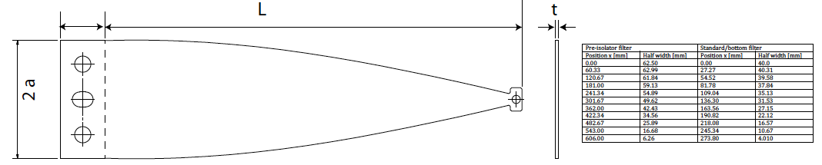 Figure 9: Typical blade profile, the length L was 283 mm for the standard and bottom filters and 615 mm for the top filter, the half width a is shown in the table, the nominal thickness t was 2.4 mm for the standard and bottom filters and 5 mm for the top filter. The table shows the values used to cut the blade profiles. The blades are flat at production; their profile is calculated so that the blade assumes an almost constant bending radius, i.e. stress level, under load.

Frequency tuning procedure
The filter tuning procedure is an iterative process. Details of the filter assembly procedures are given in [ ]. After all blades are pre-stressed and mounted on against the filter’s keystone and secured, the filter is loaded with a dummy load until it floats. Then the load is changed in small steps until the height corresponding to the minimum resonant frequency at that blade’s radial compression is identified. This operation is illustrated in figure “Search of the Filter working point”. This point corresponds to the maximal compression of the blades and is called filter’s working point. Working point, height, resonant frequency, load mass and radial compression are recorded. Once a working point is identified, the effective spring constant of the GAS filter is tuned by mechanical adjustment of the blade radial compression. This determines the filter’s natural frequency. The tuning process is an alternance of measuring the natural frequency and changing the compression of the blade springs until the desired frequency value is achieved. The payload remains constant during the radial compression tuning. Two opposing buckled blades are always compressed at the same time. At each step the sliding clamps are released, the clamp is advanced by turning the tuning bolts pushing on the back of the clamp of each blade pair, then the clamp is tightened again. The radial compression is conventionally measured as the distance between the back surfaces of the blade base clamp and the back of the two clamps that hold it onto the top surface of filter’s base disk.
The sequence of working points as a function of radial compression follows the square root function of figure “Resonant frequency at the working point”. This function reflects the fact that the anti-spring coefficient K_{as} is a geometrical effect proportional to the radial compression, as discussed in [].
Each GAS filter is tuned separately to achieve a natural frequency around 200 mHz at its nominal load (about 320 kg for a typical filter loaded with all blades). The natural frequency, fn, of GAS filters can be approximated similar to a harmonic oscillator:
fn= ½ π √(κ /m)
with the vertical spring constant, κ, and the payload mass, m. By stepwise adjusting the compression rate of the blades, a GAS filter floating 320 kg reaches its nominal spring constant of about κ ≈ 400 N/m at a natural frequency of fn ≈ 180 mHz. At this tuning, for small displacements, the GAS filter behaves like a harmonic oscillator. Hence, according to:
κ = mg/ x
the height changes by x ≈ 2 mm for a payload change of m ≈ 110 g.
The maximum vertical displacement range is limited by end-stops at ±5 mm. Because the GAS filter is a non-linear device, its stiffness increases substantially when the keystone deviates from the working point. The working point of a standard filter is ~85 mm between the keystone’s lower surface and the GAS filter plate’s upper surface. It is used as a zero point setting for the vertical displacement sensor (LVDT).

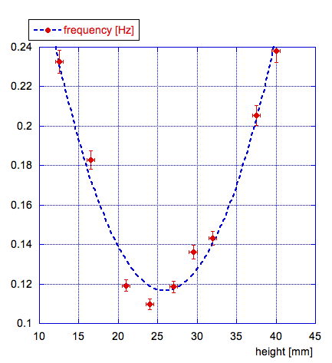
Figure 10: Search of the Filter working point. The different heights are obtained by adding or removing small masses, typically one or few 100 g.
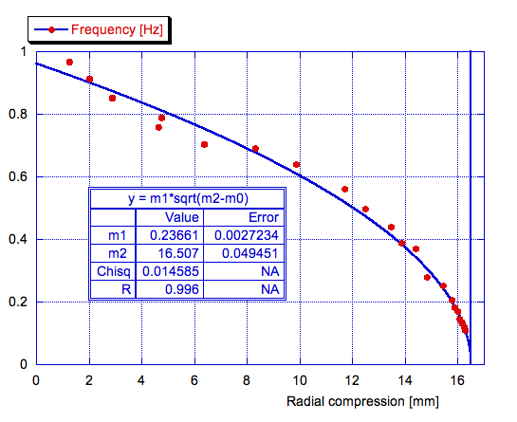
Figure 11: Resonant frequency at the working point versus radial compression of a pre-isolator filter.

Center of percussion cancellation.
The TAMA-SAS filters were limited at 60 dB of attenuation by the blade’s center of percussion effect, initially recognized only for inverted pendulums [- - ]. Once recognized this limiting effect in the filter blades, the effect was neutralized implementing counterweighted beams, called magic wands []. The magic wands, illustrated in figure “Magic wand for center of percussion cancellation”, are tuned by shifting the counterweights at the back along a fine-threaded shaft. All GAS filters after TAMA were equipped with these magic wands for center of percussion cancellation, which extended the filter attenuation power to more than 80 dB. The magic wands have been thoroughly field tested in AEI-SAS and NIKHEF-SAS [].
Do we have a tuning curve for the magic wand?
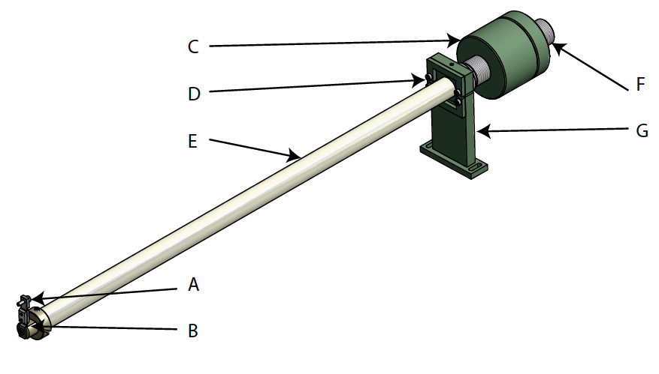
Figure 12: Magic wand for center of percussion cancellation; A: Attachment point to the keystone, B: Nose flexure, C: Tunable position counterweights, D: Stand flexures (a pair), E: Silicon carbide tube, F: Threaded sleeve for counterweight position tuning, G: Stand.
Vertical position sensing and actuating.
The GAS filters are equipped with coaxial LVDT position sensors [] and collocated voice coil actuators [], mounted below the keystone. The LVDT and voice coil actuators serve many uses. They can be used for calibration and diagnostics, configured into electro magnetic springs to dynamically change the filter resonant frequency, to monitor the filter’s working point and to mitigate the ill effects of Dislocation Self Organized Criticality.
To add: typical LVDT sensitivity in nm/√Hz
Actuator force numbers (N/A)
Diagnostics
One of the greater risks during assembly of an attenuation chain is the accidental rubbing of cables between themselves or against outer structures. The best diagnostics against this danger is to oscillate the filters with large amplitude and monitor the oscillation free decay. Any rubbing is immediately visible in the form of deviations from the expected exponential decay. The excitation is made using the actuator, and monitoring the decay with the LVDT. Individual filters in a chain can be tested by using the LVDT and actuators of the other filters to actively freeze them and keep them from participating to the oscillation.
Electro Magnetic Anti Springs
The vertical resonant frequency can be dynamically changed, and lower frequencies can be achieved, by applying linear feedback between the LVDT and the actuator[]. This feedback is equivalent to the addition of a correction spring in parallel to the suspension blades. The elastic constant of this spring is determined by the feedback gain and can be either positive or negative. A fixed current in the actuator can be used to temporarily shift the filter' equilibrium point. Use of the electromagnetic springs should be limited as much as possible because they can inject electronics noise in the mechanics, and because the waste heat from standing currents in the coil can disturb the filter’s tuning. Ideally the actuators should be turned off during normal observatory operation.
Thermal tuning
Virdone [] has measured a thermal variation of the Young’s modulus of 2.023(±0.013) 10⁻⁴ ºC⁻¹ in Maraging blade filters. Large changes of the working point are caused by small temperature changes. The vertical movement for a fixed change of temperature grows with the inverse of the square of the frequency tune. In a laboratory, the equilibrium point of a filter tuned to low frequency fluctuates by several mm around the working point tracking the variations of ambient temperature. The filter’s equilibrium point is much more stable in vacuum, where thermal fluctuations are reduced, and even better stability is expected in underground locations, where thermal stability of a fraction of milli-Kelvin can be reached after sufficient stabilization time. The thermal variation of the Young’s modulus can be taken advantage of to finely tune the filter’s working point. This is done by controlling the vacuum tank temperature around the filter with thermal pads. The locations of these pads are illustrated in figure “Type-A seismic attenuation chain”. They consist in a couple of loops of 6 mm stainless steel tube tightly wrapped around the pipe, covered by thermal insulation. Stabilized temperature water is flown into the tubes. A Peltier heat pump between the input and output flow allow extra fine temperature tuning. The safety structure above and below the standard filters was designed to act as thermal baffles that define an individual thermal bath around each filter. The temperature is changed very slowly until the monitor LVDT reads the desired working point of the filter.
A stepper motor controlled, tunable parasitic spring is foreseen to tune the equilibrium point of the pre-attenuator filter. (figure “Stepper-motor-controlled parasite”).

Limitations of vertical filter low frequency tuning.
While it is theoretically possible to set the radial compression for very low resonant frequencies, instabilities appear at low frequency, generated by the dislocation’s collective activity inside the material []. The thermal drifts in the laboratory are sufficient to continuously rearrange large amounts of dislocations. This dislocation
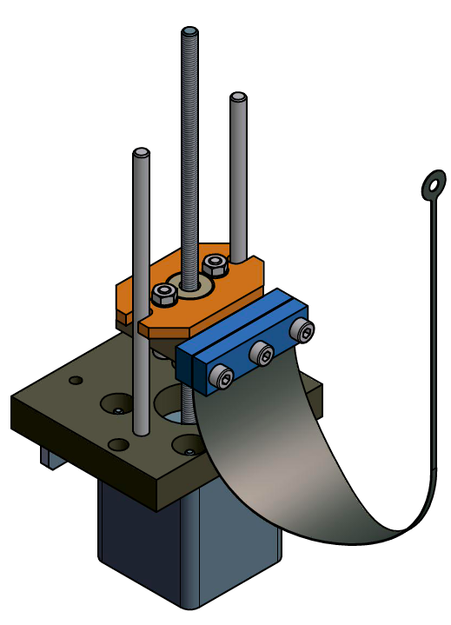
Figure 13: Stepper-motor-controlled parasite vertical blade, for working point tuning of the pre-isolator filter. The motor is attached to the filter base plate, the tip of the spring to the keystone. The blade is flat at production. The blade’s profile is calculated to give it circular bending around when under tension.

activity causes stochastically growing dislocation entanglements and, eventually, instabilities. The average time before instability events depends strongly on the frequency tune, on the amplitude and frequency of temperature oscillations, as well as other perturbations. This makes it practically impossible, in an open laboratory, to stably tune a GAS filter much below 200 mHz for a larger pre-isolator filter and much below 300 mHz for a standard filter.
Laboratory pre-set resonant frequencies of 200 to 300 mHz are sufficient for the attenuation chains in KAGRA, which contain short pendulums. In the type-A, standard filters tuned below 300 mHz already match the 0.33 Hz resonant frequency of the 2.25 m long pendulums in the chain. It is useful to implement lower frequency tune of the vertical springs not only for the added attenuation power, but also because the lower frequency tuning rapidly introduce strong internal damping in the material (see figure “Quality factor versus frequency”). This internal damping reduces the r.m.s. motion of the chain in the vertical direction.

Tuning filters to very low frequency
More aggressive low-frequency tuning may be useful for possible low-frequency upgrades of KAGRA, but it will be a necessity for future gravitational wave detectors, sensitive to lower frequencies. Lower frequency tunes are possible when operating filters in vacuum, with tight temperature control and full LVDT/actuator, following the procedure outlined in the next chapter. A pilot in vacuum test of the HAM-SAS demonstrated operation of standard filters close to 10 mHz vertical frequency for several hours []. More tests will be necessary to establish a suitable procedure and the reliability of these tunings. A better solution would be to use elastic materials free of dislocations, and therefore free of instabilities; no such material is identified, at present, although some bulk glassy metals are good candidates[].
Refer to or add measurements with Alessandro’s thermoelastic.
Add filter transfer function measurements or references to measurement papers as convenient.
(Takanori, Alexander, Alessandro, etc.)
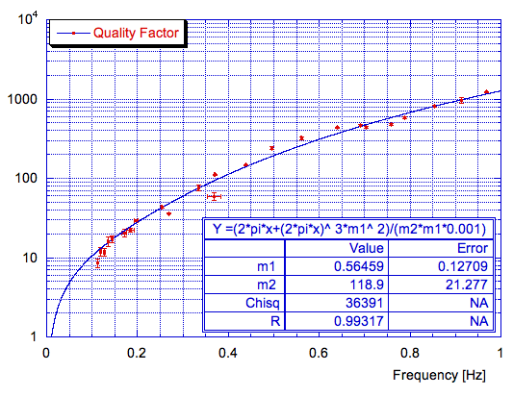
Figure 14. Quality factor versus frequency in a pre-attenuator filter.
Controlling Self Organized Criticality instabilities.
Probably the most important function of the LVDT and voice coil actuators is to allow mitigation of the instability problems associated with dislocation Self Organized Criticality of Dislocation inside the cantilever springs metal []. It has been observed that GAS springs have strong hysteresis [], and that metastable equilibrium points exist around a true equilibrium point. It has also been shown in the same paper that the true equilibrium point can be found by causing the filter to oscillate with large amplitude. The hysteretic behavior is enhanced by the low frequency operation of GAS filters.
It was later shown that this behavior is not limited to Maraging, nor to the GAS geometry [] and that forced oscillations mitigate the hysteresis problem [ - ].
The same paper showed how a filter, which is not operated at its “true” equilibrium point becomes unstable when it is tuned lower than 200 mHz. This is because, unless the filter is at its “true” equilibrium point, spontaneous avalanches of dislocation randomly shift the metastable equilibrium point and may produce chaotic instability. Similar instability behaviors are observed in different fields of physics, for a nice review, see Motter and Campbell []. Because thermal shifts cause continuous drifts of the “true” equilibrium point of a filter, instabilities are unavoidable in absence of tight temperature control.
It is important to tune the resonant frequency of vertical frequency at lower frequency, thus increasing the filter’s attenuation power. This is especially relevant for the pre-isolators, which are intended to attenuate the micro-seismic noise peak between 100 and 300 mHz, and for future lower frequency gravitational wave detectors. The limitation imposed by SOC instability seem to preclude this possibility. These limitations can be overcome by the judicious use of the LVDT sensor and voice coil actuators in conjunction with tight thermal control.
The true equilibrium point of a filter can be changed by changing the load, the operating temperature (via the thermal changes the metal Young’s modulus) or by applying static forces on the filter. After a filter load is adjusted and the filter is under vacuum, the “true” equilibrium point is found by generating a controlled forced oscillation. The filter true equilibrium point is then brought to coincide with the working point (the height with maximal radial compression) by acting on the ambient temperature. A final, large-amplitude, forced oscillation cycle is applied to smooth out the dislocation landscape, impeding instabilities and making sure that the filter is at its “true” equilibrium point. In these conditions a filter can be operated at lower resonant frequency.
Low frequency operation of GAS filters is feasible; in HAM-SAS four GAS filters were stably operated at 30 mHz for hours[], even without prior flattening of the dislocation landscape with the forced oscillations.

The seemingly insoluble tuning problem.
It has been observed that even small temperature changes (<1ºC) easily change the true equilibrium point and destabilize the filter. It is clear then that GAS filters can be operated at low frequency only in vacuum where very tight thermal stabilization is possible. It remains the practical problem that a filter tuned to very low frequency is unstable in laboratory conditions and therefore cannot be tuned in the first place. In addition the delicate process of radial compression tuning is impossible in vacuum where stable temperature conditions are achievable.
The use of Mantovani’s electromagnetic anti springs [] to lower the resonant frequency is not satisfactory because it re-injects position sensor noise in the chain, a real problem for filters down the attenuation chain. The opposite scheme can be applied. Using negative gain one can make the elastic constant of a filter larger, maintaining it above the stability frequency even when the filter is mechanically tuned at a frequency unstable in normal laboratory conditions. One can determine with great precision the frequency of the mechanical tune of the filter by changing the gain of the electromagnetic spring and performing a measurement similar to that of figure “Resonant frequency at the working point”.
After implementation of the attenuation chain in vacuum, the true equilibrium of a filter is brought to coincide to the filter working point by means a constant current in the actuator, then the current of the actuator is nulled by slowly varying the temperature and periodically performing the forced oscillation sequence of the filter to sweep out any accumulation of dislocations. Finally the electromagnetic spring gain is ramped down, the voice coil actuators are turned off and the filter is left operating at low frequency. By performing the forced oscillation procedure on pairs of filters with equal but opposite amplitudes, it is possible to exercise the filters without moving the delicate optical payload.
This scheme will thus allow passive operation of the springs at lower resonant frequency. Tests are needed to determine the lowest stable operating frequency that can be achieved. Based on experience hysteresis stability studies[ - ], the dislocation landscape flattened by the oscillation procedure is expected to remain stable, until temperature fluctuations occur, or an accidental mechanical movement occurs. Both events are rare in an attenuation chain, in vacuum and can be be.

Vertical filters Performance summary
The geometric anti-springs used in KAGRA’s filters are completely Ultra High Vacuum compatible and, unlike the magnetic anti springs of the Superattenuators, do not require the differential vacuum that was necessary in Virgo.
As a result of implementation of the magic wands, each filter used in KAGRA’s attenuation chains provide ~40 dB more attenuation than the Virgo superattenuator filters a performance almost twice as good, and >20 dB more attenuation than the TAMA-SAS filters, which is sufficient to satisfy the requirements for KAGRA.
The better understanding of dislocation in self organized criticality regime and the implementation of LVDT position sensors and voice-coil actuators will allow the tuning of the frequency of even KAGRA’s vertical attenuation filters below the 100 mHz mark. This will be important for the Einstein Telescope. Better materials, not dominated by dislocation activity, like glassy metals, should be considered for filters operating at very low frequency.

Pre-isolator filter details
The pre-isolator filters in the type-A and type-B chains differ only on the number and width of their suspension blades, 6 blades for the four type-A filters and 3 blades for the seven type-B.
The pre-isolator filters are provided with a stepper-motor-controlled parasite vertical spring illustrated in figure “Stepper-motor-controlled parasite vertical blade” that is used to adjust the height of the mirror. This movement is done at the price of moving the filter slightly off its best working point, a down side that can be corrected with a suitably profiled electromagnetic spring.
In addition the pre-isolator filter is provided with a rotation mechanism that align the yaw of the mirror to the beam axis. The rotation mechanism is illustrated in figure “Exploded view of rotation mechanism”. The suspension wire head holder rests on a ceramic ball thrust bearing, and rotation is achieved by means of a stepper motor pushing on an arm.
The pre-isolator filter keystone is also provided with a support structure for an optional vertical inertial sensor.
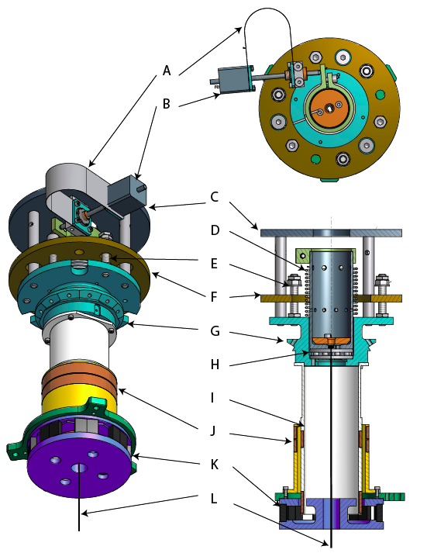
Figure 15: Exploded view of rotation mechanism in the pre-isolator filter core: A: Anti-rotation spring for stepper motor, B: Stepper motor for suspension wire rotation, C: Vertical seismometer platform (optional), D: suspension wire rotation restoring spring, E: Keystone end of range tuning screw (one of 3 for upper end and 3 for lower end), F: Keystone range limiting plate, attached to filter main base-plate, not shown), G: Keystone, receiving the noses of the blade springs, H: trust bearing of suspension wire rotation mechanism, I tube supporting the LVDT primary coil and at the bottom the actuator coil, J: LVDT secondary coil pair, K: actuator permanent magnets and Yoke, L: Nail head suspension wire.
Standard filter details

The standard filter is a smaller version of the pre-isolator filter, enclosed by a cap that allows suspension of the filter from its center of mass. The filter is designed so that the working point of the filter falls close to the center of mass, so that the rocking modes of the filter body are at low frequency. Although the heads of the suspending and suspended wires are few mm apart, and the heads each 4 mm thick, due to the wire rigidity, the separation of the effective bending points is ~ 40 mm. As a result the standard filter rocking mode frequency is at 1-2 Hz. The rocking mode frequency can be lowered by changing the shape of the two wire receptacles to move the effective bending point below the filter’s center of mass by an appropriate amount.
The standard filter is provided with magic wands and with LVDT and voice coils.
In KAGRA a single standard filter is foreseen in the seven type-B attenuation chains, and 3 standard filters are used in the four type-A chains, for a total of 19 standard filters.
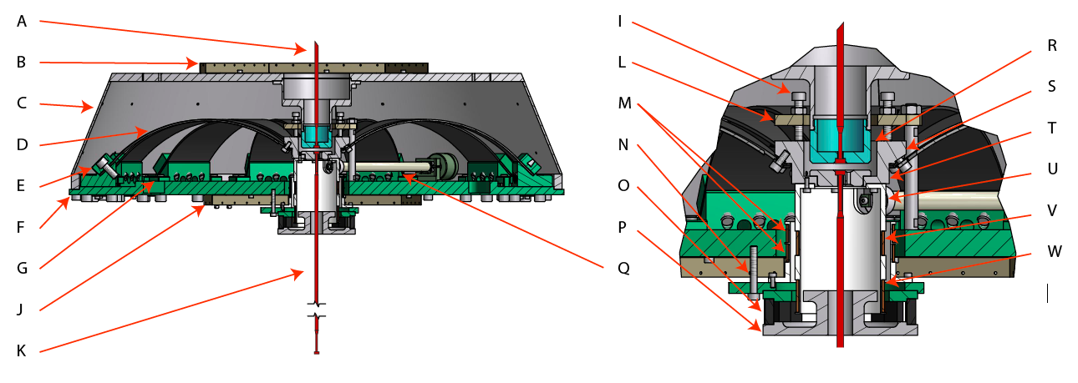
Figure 16: Standard filter; A: wire suspending the filter, B: upper electrical wiring rack, C: filter outer shell, D: cantilever blades (4 to 12 depending on load), E: Blade’s 45º clamp, F: Filter’s base disk, G: sliding clamp for radial compression of blades and filter frequency tuning, J: lower electrical wiring rack, K: wire suspending the next filter, I: range limiting screw (upper range, one out of three, lower range screws not shown), L: Range limiting plate, M: LVDT secondary coils, N: LVDT-zero tuning screw (one out of three pulling, pusher screws not shown), O: permanent magnet, P: voice coil actuator magnet yoke, Q: magic wand, R: suspension wire receptacle, S: suspended wire receptacle, T: Keystone with 33o blade’s nose attachment point, U: LVDT primary and voice coil actuator coil support tube, V: LVDT primary coil, W: voice coil actuator coil.
Bottom filter details
The mechanics of the bottom filter are virtually identical to a standard filter, with the exclusion of the magic wands, and the addition of a number of control features, discussed in the mirror suspension chapter.

Measurements and performances of the standard filters
Please add measurements and calibrations.

Eddy current damping.

The need of chain modes damping
One of the most serious concerns in tall single wire suspension is the excitation of the torsion (yaw) modes of the wires. Single wire suspensions allow a suspended filter to be isolated in all six Degrees of Freedom. However, a long wire suspension becomes quite soft in rotation around the vertical axis. The wire torsion modes have extremely low resonant frequencies (<10 mHz in Virgo) and very high Q factors, therefore the decay time can be crucially long (hours). These modes are easily excited by mistakes of control actuation at the inverted pendulum level, or radiation pressure of the laser, and once they are excited one has to wait until they decay to sufficiently small amplitude for a new interferometer lock acquisition. Damping of the torsion modes is absolutely necessary for efficient operation of gravitational wave detectors.
Virgo suffered from this problem and an external active damping system operating near the bottom of the chain had to retroactively implemented.
In TAMA-SAS, an active control using photo sensors and coil-magnet actuators was implemented for torsion mode damping []. This method works effectively and reduces the decay time of the torsion modes by a factor of 10 or more, while it is limited by range of photo sensors and therefore stops operating whenever large angular excursions occur.
In order to avoid the above-mentioned problem in KAGRA-SAS, the torsion modes are damped passively by an eddy current damper mounted at the head of the chain.
The main function of the pre-isolator is to reduce the r.m.s. movement of the mirror to within the range of the mirror actuators, i.e. to reduce the excitation level of the suspension chain modes to a small fraction of a µm in position and a small fraction of a µm/s in speed, to allow lock acquisition. That mirror motion is dominated by the residual excitation of the attenuation chain resonances, which have large quality factors and very long self-damping times. The Eddy current damper was designed to damp these modes as well.

Design of the Eddy current damper.
An additional standard filter is inserted below the pre-attenuator stage for the specific purpose of providing means to damp the torsional resonances. A high conductivity, 10 mm thick, OHFC copper ring is bolted on the top surface of the filter (see figure “Conceptual design of torsion”). The magnetic part of the Eddy current damper is composed by a heavy, soft iron ring suspended from the bottom of the pre-isolator by means of three wires. Its lower surface is loaded with clusters of 12.5 mm cube magnets. The magnets are in group of 4 or 16, with vertically oriented dipoles, 25 mm pitch and alternate polarity to cancel the dipole, quadruple and higher order fields at large distance while extending magnetic field loops with strong gradients 10 mm from their lower surface, but rapidly decreasing strength at larger distances. The copper ring is close enough to intercept a large fraction of the magnetic field loops. Any differential motion between the two plates produces braking torques. Although the damping torque is exerted only between the pre-isolator and the first stage, with a proper choice of wire torsional stiffness, the rotational motions of the lower stages are also damped. The positioning of the damper at the head of the chain eliminates any danger of feeding damper noise to the mirrors.
The type-A and type-B Eddy current dampers differ only for the length of the disk suspension wires, from 955 mm in the type-B to ~1947 mm in the type-A.
The separation between the hovering magnets and the copper ring is tunable to change the damping strength.

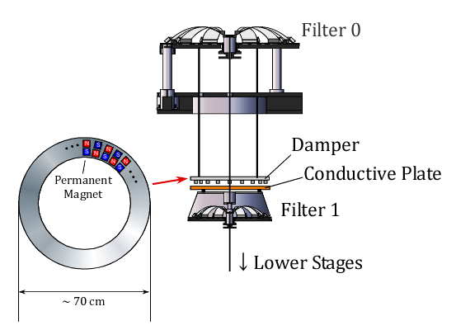
Figure 17. Conceptual design of torsion mode damper.

New wire geometry.
Eddy damping is proportional to the speed. It was found in Virgo that using filter suspension wires of constant diameter produced yaw resonances of excessively low frequency. That would have rendered the Eddy current scheme ineffective.
To keep the yaw resonant frequency from further decreasing with growing wire length, the wires were made thin only near their attachment point, where they need to form a soft pendulum flexure, and left thicker elsewhere, see figure “Main suspension wire design”. This way most of the wire length is too rigid to contribute to determine the yaw resonant frequencies. The yaw frequencies of the chain become much higher and largely independent of the wire length. Since the torsional stiffness depends strongly on wire thickness at the bottleneck, one can also optimize the angular stiffness of each wire to couple all torsional modes to the Eddy current damper.
The torsional stiffness of the wire of circular cross section can be calculated by the following equation:
.
G represents the shear modulus of the maraging composing the wire, d is the diameter and L is the length of the wire.
Thicker wires are heavier and could introduce percussion point limitations to the horizontal attenuation. It has been calculated that the added wire mass affects negligibly the pendulum attenuation performance.
Figure 18: Main suspension wire design; the wires are machined out of 7 mm diameter centerless ground maraging steel rods. They are provided with two 7 mm diameter nail heads. Below the head a neck of variable diameter D extends for 22 mm length to the wire body, 4.5 mm in diameter. The diameter D changes according to the wire’s load, from 3.1 mm diameter (7.1 mm² surface) below the top filter of the type-A to 2.2 mm diameter above the bottom filter. The different diameters are chosen to maintain the optimal stress a stress of < 0.8 GPa. The length L is chosen to match the separation between consecutive filters.
Keyhole Wire attachment.
The attachment of the nail-head wires is of new design. To limit mechanical noise and increase reliability, it is important to have purely compressive (shear free) contact between parts under stress). Clamped wires should be avoided. In the past the nail head wires were fastened to their support with a pair of half-cup inserts. This technique is still used for the top flexure of the Inverted pendulum where space is at premium, and the risk of dropping small parts in irretrievable situations is low. To ease and speed up implementation, and reduce risk, especially for the down-the-well implementation of the type-A chains, a new fastening scheme was devised.
The wire slides in on the side of a “keyhole” receptacle, and then drops into the central housing and sits tightly under load. The procedure is illustrated in figure “Cutout of a Nail Head wire attachment”. The attachment of a wire into its keyhole is very fast. In the standard filter the two wires receptacles are kept separated by spacer screws during the attachment operation. After that the nail heads are kept in their receptacle either by the wire tension, or because the two receptacles snap together is the wire tension is released. In the pre-isolator a locking cylinder (orange part in figure “Exploded view of rotation mechanism” is mounted above the keyhole to keep the wire from accidentally raising out of its seat, moving sideways and disengaging if the load is lifted during the installation procedures. The rim of the nail-head sits on ¾ of the circumference instead of all of it. The diameter of the nail head was increased from 6 to 7 mm to give more contact surface, which more than compensates for the reduction to ¾ circumference.
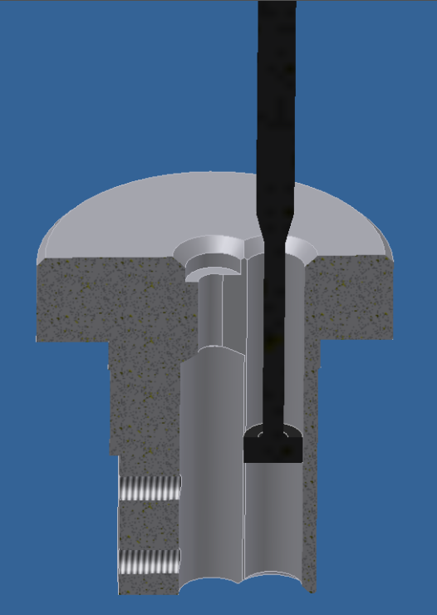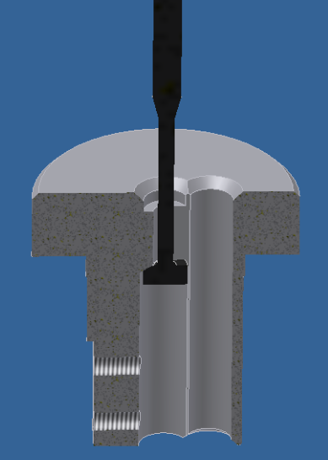
Figure 19: Cutout of a Nail Head wire attachment: The wire is inserted into the side hole, as illustrated in the left figure, then it is moved to the center and pulled up, (right figure) where it sits snugly in its housing. The nail head circumference sits with pure compressional stress over about ~5 radians and a ring contact surface 1.7 mm wide, i.e. >15 mm², for a maximum stress of 0.4 GPa.

Eddy current damping simulations.

In order to evaluate the performance of the damper, a simulation with one-dimensional pendulum model is performed. Table “Parameters used for the simulation” shows the parameters used for the simulation of the Type-A SAS. The wire diameters have been optimized for best coupling of all the resonant modes with the motion of the first stage so that they can be effectively damped. Figure “Frequency response” shows the calculated frequency response of the suspended payload to an external torque and figure “Impulse torque response” shows the impulse torque response. Table “Oscillation frequencies and decay” shows the calculated frequencies and decay times (at which the amplitudes decreases by 1/e) of resonant modes. All the torsion modes are effectively damped and the typical decay time scale is ~1 minute, which is quite short considering that the period of the resonant modes are 10~100 sec.

 | D [mm] | L [m] | k_{t} [Nm/rad] | I [kg m²] | γ [kg m²/sec]
Stage 1 | 3.1 | 2.27 | 0.30 | 7.4 | 2.0
Stage 2 | 3.8 | 2.27 | 0.65 | 6.8 | -
Stage 3 | 3.8 | 2.27 | 0.65 | 6.6 | -
Stage 4 | 3.8 | 1.99 | 0.68 | 6.4 | -
Stage 5 | 3.5 | 3.47 | 0.29 | 3.2 | -
Payload | 1.3 | 0.40 | 0.036 | 0.50 | -
Table 1: Parameters used for the simulation. D: wire diameter, L: wire length, k_{t}: torsional stiffness of the wire, I: moment of inertia of the suspended mass, γ: damping coefficient.
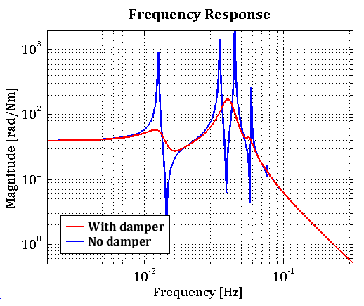
Figure 20: Frequency response of the suspended optical payload to an external torque.
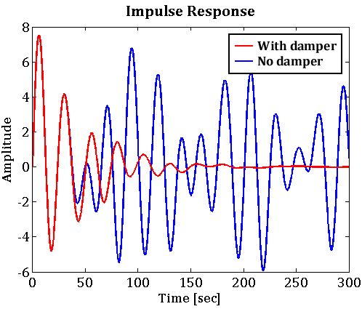
Figure 21: Impulse torque response of the suspended optical payload.

Frequency [mHz] | Q-factor | Decay Time [sec]
12.9 | 3.1 | 76
39.8 | 3.4 | 27
40.3 | 3.8 | 30
56.4 | 7.4 | 42
73.2 | 10.1 | 44
91.8 | 7.8 | 27
Table 2: Oscillation frequencies and decay times of torsional resonant modes in the damped system

The eddy current damper affects not only on the torsion modes but also on the other pendulum modes of the chain. Figure “Transfer function from ground” shows a simulated transfer function of the horizontal displacement from the ground to the mirror in type-A system. The Q-factors of some pendulum modes are suppressed by factors of ~10. These modes can be further damped by active control system on the top stage. Please note that the quality factors calculated for the damped modes represent are reliable upper limits because they derive from an easily achievable damping factor γ of the first stage. The quality factors without the damper are somewhat arbitrary. The quality factors of these pendulum modes are likely higher than shown in the graph, especially under vacuum conditions.

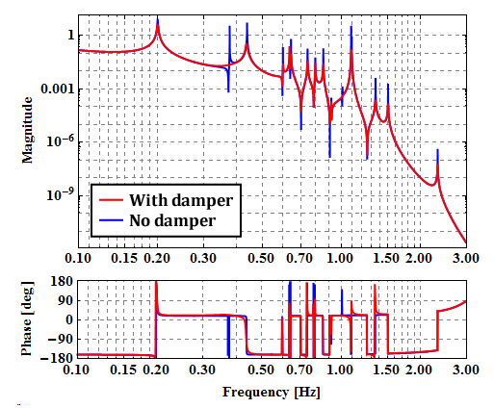
Figure 22: Transfer function from ground displacement to the mirror displacement in Type-A system.

Torsion mode damping for beam splitter and recycler mirrors

The beam splitter and recycler mirror optical payload have relatively small moment of inertia. In order to make all the resonant modes couple to the damper, the torsional stiffness of the wire suspending the Intermediate Mass must be tuned quite precisely to match the moment of inertia of each stage. If all stages had similar moment of inertia, one would not need precision tuning of the wire diameter, but because the optical payload has 10 times smaller moment of inertia than other stages an error of just 0.1 mm on the wire diameter makes quite large difference in decay time, as illustrated inFigure “Frequency response of the suspended payload” and Table “Comparison of longest decay”.
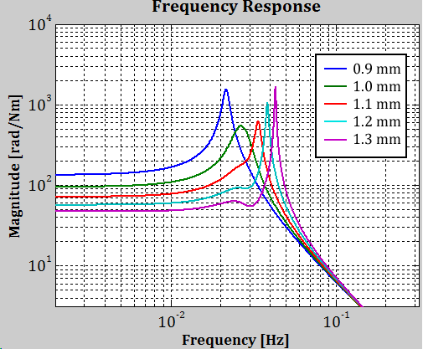
Figure 23 Frequency response of the suspended payload to an external torque in Type-B1 SAS with various diameters of IM suspension wire.
Wire Diameter [mm] | Decay Time [sec]
0.9 | 171
1.0 | 52
1.1 | 129
1.2 | 257
1.3 | 444
Table 3: Comparison of longest decay time with various IM suspension wire.
The simulations of the shorter type B SAS are substantially similar from those of the longer type A. The parameter used are listed in table “Parameters used for Type-B” and the results illustrated in figures “Frequency response of the suspended payload to an external torque in Type-B SAS” to figure “Transfer function from ground displacement to the mirror displacement in Type-B” and table “Oscillation frequencies and decay times of resonant modes in Type-B”
 | D [mm] | L [m] | k_{t} [Nm/rad] | I [kg m²] | γ [kg m²/sec]
Stage 1 | 2.3 | 1.28 | 0.16 | 7.3 | 3.0
Stage 2 | 2.0 | 0.51 | 0.21 | 6.8 | -
Payload-Beam Splitter | 1.2 | 0.61 | 0.025 | 1.3 | -
Payload-Recycler mirrors | 1.0 | 0.58 | 0.012 | 0.42 | -
Table 4: Parameters used for Type-B SAS simulation.
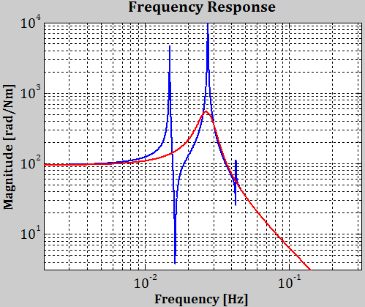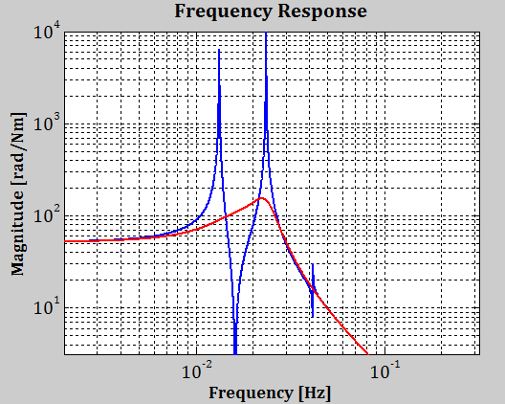
Figure 24: Frequency response of the suspended payload to an external torque in Type-B SAS. Left recycler mirror, right Beam splitter mirror.

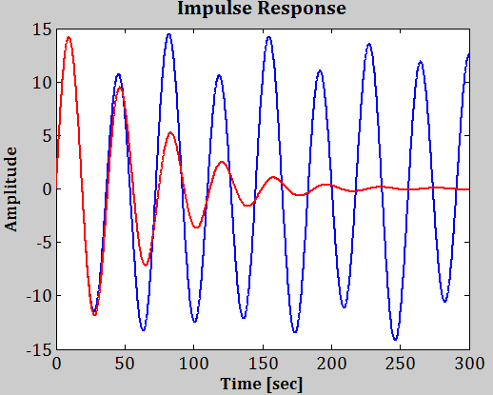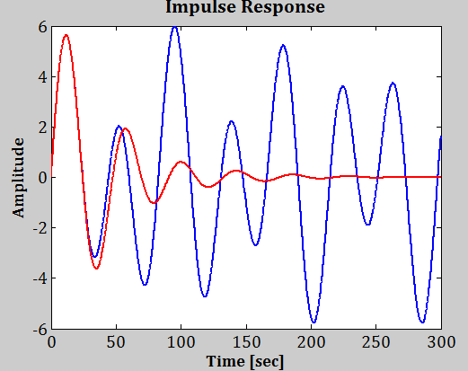
Figure 25: Impulse torque response of the suspended payload in Type-B SAS. Left recycler mirror, right Beam splitter mirror.
Frequency [mHz] | Q-factor | Decay Time [sec]
15.8 | 1.3 | 25
23.2 | 3.3 | 45
30.5 | 1.3 | 14
Table 5: Oscillation frequencies and decay times of resonant modes in Type-B SAS.
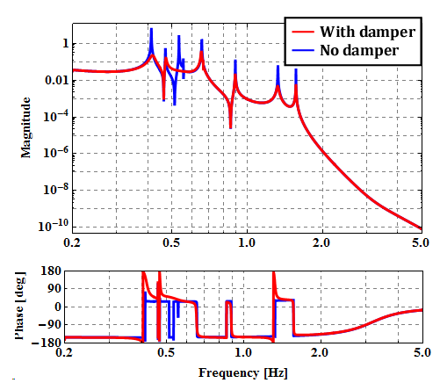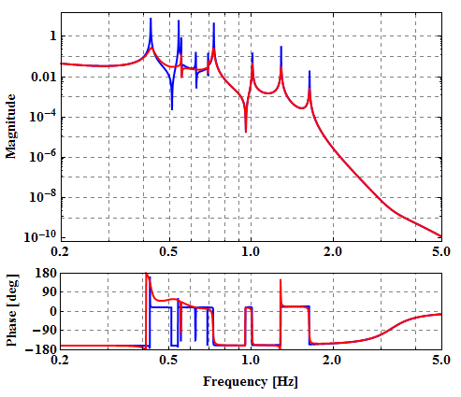
Figure 26: Transfer function from ground displacement to the mirror displacement in Type-B system

Overall scheme of type-A Double tunnel solution.
As already mentioned the double tunnel solution is required by the necessity to solidly seat the heads of the attenuation chains, which is impossible for the attenuation chains of the four test masses due to the presence of the cryostats and cryopumps where the footing should be. The double tunnel solution thus imposes the overall attenuation chain length, which is equal to the ceiling height of the lower chamber (8m), plus the minimal thickness of rock required between the two excavations (5m), plus the height of the chain head from its footing (~1.5m), minus the height of the beamline above the floor of the lower chamber. In KAGRA this length is about 12m, which is more than required to achieve the required attenuation in the required frequency range (above 10 Hz).

The problem of the chain’s pendulum motion.
The fundamental resonant frequency of a 12 m long pendulum F_{pend}
F_{pend}=2π√(g/l) = 143 mHz.
Because of the mass distribution along the chain, the actual frequency is somewhat higher, ~ 200 mHz, as can be seen in figure “Transfer function from ground displacement to the mirror displacement in Type-A system”
In both cases the resonance falls just about in the microseismic peak range and during bad “seismic weather” the pendulum can be excited to large amplitudes, thus impeding lock acquisition. Simulation shows that, although some damping occurs, this mode is too slow to be rapidly damped by the Eddy currents. Active damping is necessary for this mode.
The inverted pendulum voice coil actuators are almost ideal tools for this task, because they act at the head of the attenuation chain, at the point where the seismic excitation would be injected. Active damping requires an sensor providing a suitable, actionable signal. Various options are possible to sense the low frequency oscillations of the chain. Inertial sensors on the Inverted pendulum, sensing the recoil of the oscillation, and position sensors along the chain can be used.
Inertial sensors like geophones have limited sensitivity at the microseismic peak, and are sensitive to ground tilt noise.
The inverted pendulum LVDT position sensors measuring the ground to inverted pendulum table distance may appear to be ideally located, and adequately sensitive (nanometer resolution). Unfortunately they alone are not suitable because they cannot distinguish if the relative motion between the inverted pendulum table and ground is due to seismic motion or to recoil against the attenuation chain oscillations. To sense the oscillations, additional ground-to-chain position sensors are necessary along the chain. The natural places where these sensors can be positioned are where the suspension wire crosses the ceiling of the lower chamber, and at the level of the suspended mirror.
In the first location the suspension wire motion can be sensed with a shadowmeter bolted to the ceiling of the hall. In Virgo the length sensing (before lock) at the mirror is made by means of the optical levers. In Virgo, the optical lever angle is about 45º. Consequently the Virgo optical levers mix the angular and longitudinal signals. The two signals are easily separated by reading the return beam position both in the focal plane of a lens where parallel beams are concentrated in a point (and therefore the image position is insensitive to beam’s transversal motion) and on the unfocussed beam, where transversal motion is fully visible. The same can be done on the KAGRA’s recycler beams, but not in the more important main mirrors, where the optical lever beam angle is very small (few deg). In this case a secondary beam is necessary, and the length sensing can be done only with fringe counting and/or digital interferometry. The rock to mirror length-sensing signal has an independent importance during lock. The locked interferometer arm can be considered as a rigid and inertial rod. During lock acquisition the rock is used to stabilize the mirror. During lock the seismic movement of rock is detected, which is an important piece of information because it continuously measure how much rock enters the volume between the mirrors and how much exits, thus giving a very useful Newtonian Noise input signal.

Inertial damping.
(Takanori, maybe a separate chapter?)

Shadowmeter pendulum mode damping.
A shadowmeter measuring the movement of the suspension chain wire with respect to the rock in the lower chamber is foreseen. The shadowmeter beam launchers and position sensitive receivers are placed on the roof of the lower chamber, 6-7m below the head of the attenuation chain, at about ½ of its length, and therefore measure its fundamental mode movement with roughly 50%, but fixed, de-amplification. The 4.5 mm suspension wire provides an ideal shadowing flag. The shadowmeter is composed by a fiber-fed launching telescope, similar to the ones used for the optical levers of the interferometer, solidly attached to the lower chamber ceiling rock. The telescope launches a thin beam that is semi-occulted by the suspension wire, and then collected by a light detector as illustrated in figure “Schematic of the shadowmeter”. Nanometer resolution is easily achievable with shadowmeters []. Two shadowmeters are mounted on each wire, in the longitudinal and transversal directions.
In an undisturbed pendulum, the differential signal of the inverted pendulum LVDT signal and of the shadowmeter measures a mix of the pendulum oscillation and the microseismic ground tilt, while the sum of the two signals measures the seismic motion itself. The noise source of this measurement is the seismic noise re-injected by the cryogenic heat-links cooling the mirrors and extracting the heat deposited by the circulating laser beams.
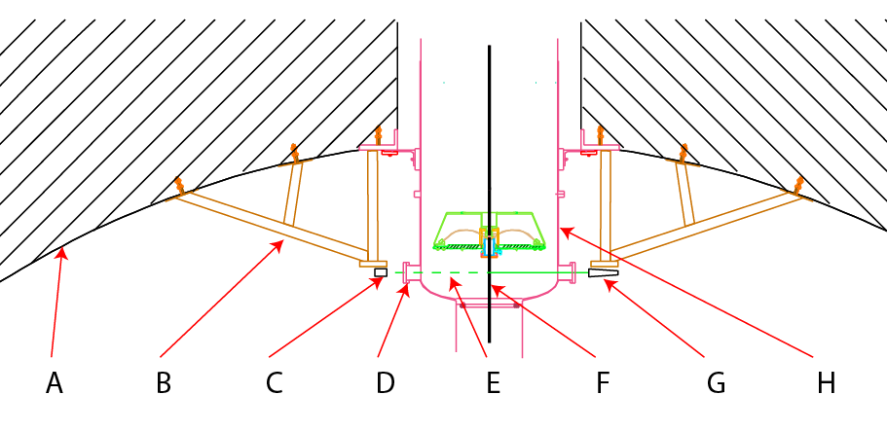
Figure 27. Schematic of the shadowmeter providing position sensing of the attenuation chain wire. A: rock ceiling, B: Rigid trusses structure, C: light detector, D: vacuum viewport, E: hemi occulted beam, F: occulting suspension wire, G: launching telescope, H: vacuum chamber.

Optical lever mirror length sensing
In Type B; in type A (Agatsuma?)
With a mix of these techniques the r.m.s. motion of the mirrors will be mitigated to the point of allowing easy lock acquisition, and the lock will be maintained with minimal actuation forces, and therefore actuation noise.

External structures
The external structures supporting the base of the attenuation chains are very important, because their resonances and movements can place an unnecessary burden on, or even defeat the effects of, the attenuation chains.

Type-A support structures
In the type-A attenuation chains, the 900 mm diameter housing vacuum pipe descends from the upper chamber into a 5 m deep, 1200 mm diameter well, which exits in the lower chamber ceiling, as illustrated in figure “Support and positioning of type-A”. To satisfy optical requirements, the well diameter is calculated to allow a ±100 mm longitudinal adjustment of the attenuation chain and hence of the main mirror. The section inside the well is supported from above, by three hydraulic pistons with mechanical stops, placed at 60º from the pre-isolator ones, on the same diameter.
To avoid pipe vibrations that could transmit to the chain, the bottom of the 900 mm pipe is clamped to the rock at the lower end of the well, and the well is refilled with thermally and sound insulating pellets. To allow easy longitudinal positioning while maintaining maximal rigidity the six hydraulic pistons are mounted on a stiff sled, sitting on rails grouted on the upper chamber floor. For initial positioning the clamps at the lower chamber roof are released, the sled is lifted on retractable wheels and the entire vacuum chamber and attenuation chain can be freely and precisely moved by means of a push-screw. Naturally this positioning requires that the cryostat below either precisely follows the movement of the head of the chain, or that it is disconnected and it is aligned to the head position at a later stage.
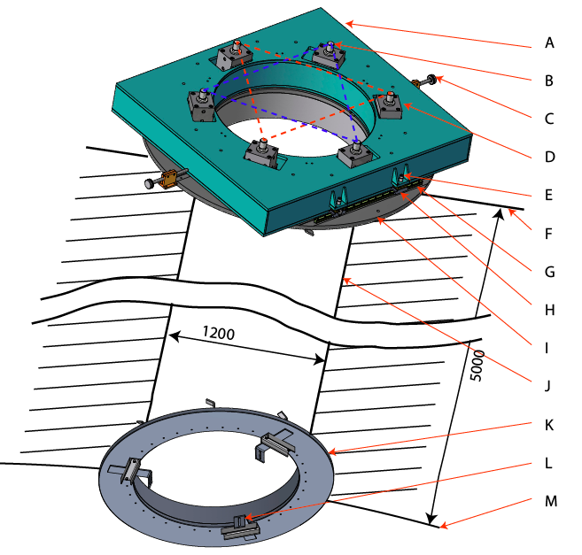
Figure 28. Support and positioning of type-A attenuation chain and vacuum chambers. A: Positioning sled, B: Hydraulic pistons (3 of) for leveling of Seismic Attenuation Chain, C: longitudinal positioning screw, D: Hydraulic pistons (3 of) for leveling of vacuum tank, E: Screw engaging translation wheels, F: floor of upper chamber, G: translation rail, H: translation wheels, I: upper platform concrete cast into floor of upper chamber, J: Well, K: lower platform concrete cast into ceiling of lower chamber, L: tunable vacuum pipe clamps, M: Ceiling of lower chamber.

Leveling Pistons.
The 100 mm diameter pistons with 20 mm stroke are actuated by a manual double action pump, injecting 3.4 cm³ of oil per (round-trip) stroke, generating a movement of 204 µm/stroke. For fine positioning a 40:1 fractional flow-divider injecting 0.08 cm³ of oil per stroke for a step of 1.87 µm/stroke. The positioning resolution’s r.m.s., as measured in figure “Calibration of the hydraulic piston system”, is <2 µm with full strokes []. It is not prudent to use the hydraulic pressure in the pistons to hold the weight because even undetectable leaks may cause progressive tilting, and because the thermal expansion coefficient of the oil is much larger than that of steel. To avoid both problems each piston is provided with a fine-thread locking ring, which is tightened by hand to offload the pressure from the cylinders after leveling is completed. The pistons can also be used dynamically for active compensation of microseismic tilt noise. In this mode of operation the mechanical stops are not engaged and actuation would be with a voice coil actuator pushing on a small diameter (10 mm) bellow in parallel to each piston.
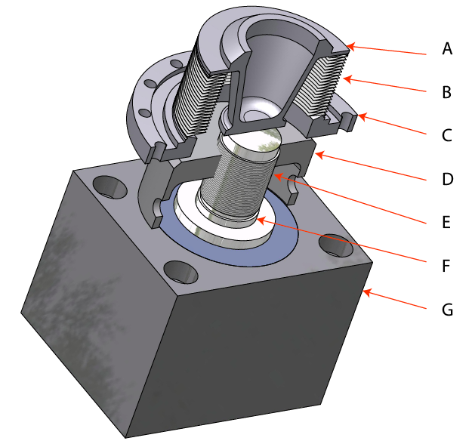
Figure 29: Height and tilt tuning Hydraulic-mechanic cylinder. A: Load transfer cone, B: Bellow, C: Vacuum flange, D: Fine thread mechanical load-holding cup, E: Fine thread shaft, F: Hydraulic piston shaft, G: hydraulic cylinder body.
Figure 30 Calibration of the hydraulic piston system. After the initial few strokes to pressurize the pistons, a linear response is observed, with slope is 1.87 µm/stroke, and a measured r.m.s. of less than 2 µm. The saw-tooth structure of the fit residuals is likely due to the reading error of the comparator used for calibration.

Type-B External support structure
Lesson learned from Virgo and LIGO teach that it is important to make sure that the support structures of the attenuation chain heads do not amplify the seismic motion and that all their unavoidable resonances are properly damped. In LIGO the slender and un-damped piers supporting the BSC External Hydraulic Active Attenuation stage actually amplify the seismic motion by more than an order of magnitude. Even the massive Inverted pendulum structure in Virgo was found to produce seismic noise amplification.
The Type-B pre-isolator needs to reside above the vacuum chamber. A rigid external structure is designed to support them, shown in figure “External structure of a type-B pre-isolator”. Two welded truncated pyramids connected by four L-beams compose it. All the edges of the sheet-metal used in the pyramid construction have folded-in lips for additional stiffness. The L-beams are over-bolted to the pyramids by a large number of bolts in a checkerboard pattern, a technical solution borrowed from the bridge best construction practices. The reason for over-bolting is that, from the point of view of vibrations, bolted interfaces are by far the weakest point of trussed structures. As a result, without over-bolting, the structure resonant frequencies would be lower than is calculated for the same welded structure, typically a factor of two lower.
The calculated first resonant frequency shown in figure “First excited mode of the external structure” is ~22 Hz with the height-tuning threaded rods retracted, it lowers to 14 Hz when utilizing the full extension of the rods []. Although the drop of resonant frequency due to bolting is mitigated by the over-bolting, resonant frequencies somewhat lower than calculated can be expected. Assuming a mechanical dissipation value 0.05 (common for bolted steel structures) and fully extended M-30 height tuning rods, the calculated horizontal seismic motion amplification on the top surface is eleven times higher than seismic motion at 14 Hz, less when the rods are fully retracted and the resonant frequency is 22 Hz.

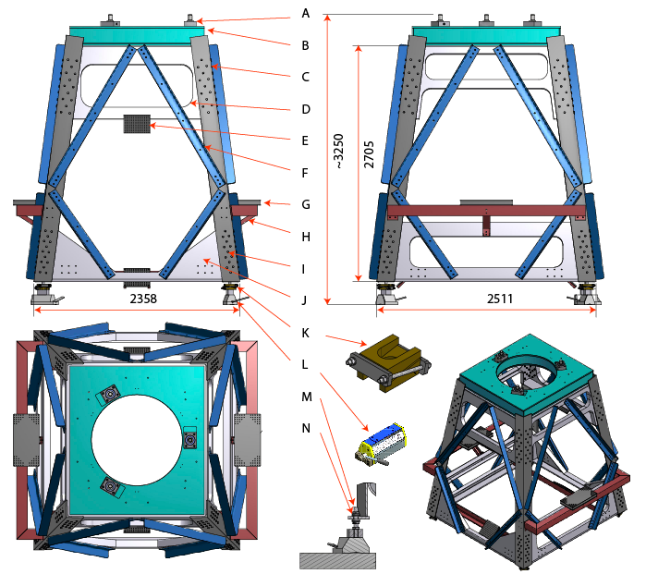
Figure 31: External structure of a type-B pre-isolator for a recycler mirror. A: Hydraulic piston for Inverted pendulum structure supported through bellows in the vacuum chamber (one of three), B: piston table, C: L-beam, D: Upper truncated pyramid structure, E: Optical lever receiving optical table, F: diagonal brace damper, with clamped constrained rubber layers, G: optical bench for extracted beams, H: damper beam, I: over-bolting checkerboard bolt pattern, J: Lower truncated pyramid structure, K: wedge stiffener, L: Magnetic foot, modified crane magnetic lifter, M: height tuning M-30 threaded rod, N: spherical washers and nuts.
Two technical solutions are implemented to mitigate the seismic motion amplification problem. Given the fact that the frequency is dominated by the rod elasticity, after the height of the structure has been tuned to the required level, four wedge stiffeners are locked between each magnetic foot and the bottom of the structure, thus “short-circuiting” the rods elasticity. To add more damping, sixteen diagonal braces are bolted between the L-beams and the pyramidal structures, with a sandwiched dissipative rubber layer in between. It was measure in a prototype structure that these cross beams damp the resonances and eliminates the seismic motion amplification problem [].
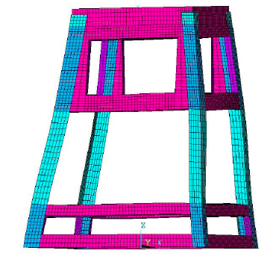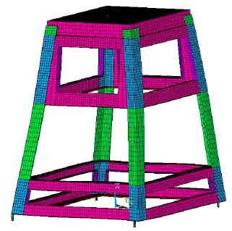
Figure 32 First excited mode of the external structure without height tuning threaded rods (22 Hz, left panel) and with them (14 Hz, right panel).
Other functions of the type-B external structure.
Magnetic footing and positioning
Optical constraints, including small variations of the recycler mirror focal lengths and of the main mirror wedge angles, will require repositioning of the recycler mirrors both longitudinally and transversally. Because the six recycler mirrors each reside at the center of its own vacuum chamber, a positioning system had to be designed to allow movement of the type-B external structure and its own vacuum chamber. The problem was solved by means of eight magnetic feet, similar to the magnetic stands used on optical benches. Each foot is made by an MHM-500-IT crane lifting magnet with a nominal lift of 5000 N and a actual holding force of 15000 N. They attach to 30 mm thick soft steel plates solidly anchored with adhesive cement to the floor of the tunnel. Each magnet is provided with an M-30 threaded rod that is connected to the base of the external structure by means of two nuts and two pairs of spherical washers. The force and rigidity of the magnet is adequate to solidly clamp the external structure to ground. About the vacuum tank footings, vacuum applied to asymmetric bellows leading to a type-B vacuum tank would easily apply a force sufficient to cause the magnetic feet to slide, or even to lift off []. Any vacuum tube bellow leading to the type-2 vacuum tank therefore needs to be immobilized by means of threaded bars before vacuum pump-down. The beam splitter external structure and vacuum chamber, which are not moveable, are bolted directly to the tunnel floor.
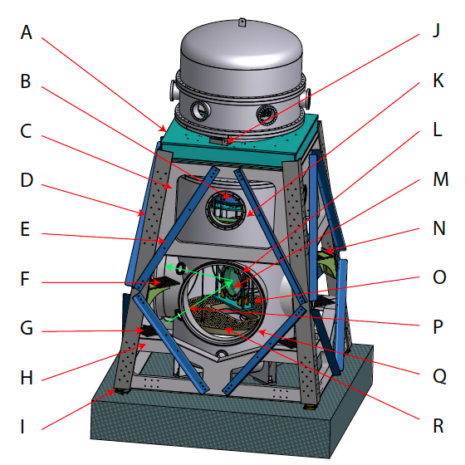
Figure 33: Beam splitter system. A: Inverted pendulum support platform, B: bottom filter, C: upper stiffening pyramid, D: L-beam structural leg,E: vibration damping cross beam, mounted on constrained layer of dissipating rubber, F: optical lever receiver shelf, G: optical lever launcher shelf, G:lower stiffening pyramid, I: height regulating foot, J: hydraulic piston leveling the inverted pendulum, K: access port, L: mirror recoil mass, M: mirror, N: monitor camera shelf, O: safety and transport structure, P: optical lever path(green arrows); Q: beamline flange, R: suspended optical bench.
Optical lever launching pads
Optical levers are used to align the interferometer in preparation for interferometer lock. They need to provide alignment of the order of 1 µradian. For this optical levers require stiff, stable and low-vibration launching and receiving pads.
This function is satisfied by the type-B external structures, which are designed to be sufficiently stable to support the small optical benches to launch and receive the optical levers. In the recycler type-B structures, the optical levers are launched from below the beam-pipe and received from above, reflecting on the front face of the mirror. In the type B-1 (recycler mirrors) the optical lever launching pads are attached to the lower and upper pyramidal sections supporting the legs and forming the external structure as visible in figure “External structure of a type-B”. In the case of the beam-splitter, because the beam splitter is rotated 45º with respect to the beam lines, the launching pads are mounted on the inner surface of one of the legs as shown in figure “Beam splitter system”.
The launching pads on the opposite side of the tank are used for the beam spot monitoring CCD cameras used to maintain the beam(s) centered in the mirror and record scattered light profiles.
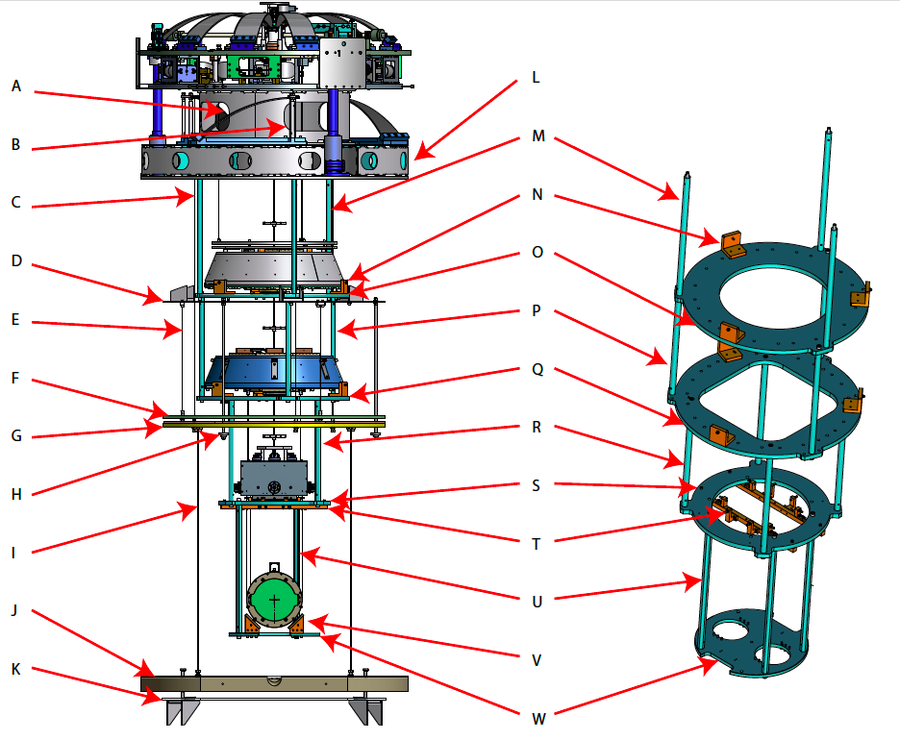
Figure 34: Suspended bench and safety structure. A: suspension spring (1 of 3), B: Spring range limiter and transport stop., C: damping ring suspension wire (1 of 3), D: Eddy current damper upper support disk and shelves welded to vacuum chamber, E: Eddy current disk suspension wire (1 of 3), F: Eddy current magnet disk, G: Damped intermediate disk, H: safety strut for intermediate disk (1 of 3), I Optical bench suspension wire (1 of 3), J: Optical bench, K: lower safety disk and shelves welded to vacuum chamber, L: Inverted pendulum base structure, supporting suspended optical bench and safety structure, M: struts, N: range limiters and transport locks for standard filter, O: standard filter safety disk, P; struts, Q: bottom filter safety disk, R: struts, S: intermediate mass safety disk, T: range limiters and transport locks for intermediate mass, U: struts, V: range limiters and transport locks for mirror recoil mass, W: safety disk for mirror recoil mass.

Suspended optical benches
The auxiliary optics are used to monitor and control the interferometer by extracting ghost beams. They must be substantially seismically isolated in order to generate low noise control and monitor signals. The auxiliary optics tables of the type-B chambers are illustrated in figure “Suspended bench and safety structure”, letters A to K. They are custom breadboards suspended from the inverted pendulum base structure with a double pendulum horizontally and vertical springs. The intermediate disk is damped via Eddy currents from a secondary suspended disk.

Safety and transport structures
The earthquake safety structure of the type-B is illustrated in figure “Suspended bench and safety structure”, letters M to W. They have two additional functions: Provide end of range stops for the movement of the suspended chain and locking mechanisms for transport and installation.
The type-A safety structures have the same functions and are similar in design.

Type-A installation procedure
The type-A attenuation chains are installed in steps from upper hall, using the safety structure as an installing tool. The installation procedure down the well is described in the report JGW-T1100410 [].

Type-B installation procedure
The type-B attenuation chains are pre assembled and tested in two sections in remote labs. The two halves of the safety structures are used keep the components of the chain from moving during transport to the underground location. The two halves are connected together and tested in a clean room. Then the entire type-B attenuation chain is raised with the crane, still using the safety structure to keep the components from moving, and lowered in its vacuum chamber. Finally the attenuation chains are released from the safety structure and are ready to operate. The installation and transport procedures are described in the report JGW-D1301485 [].
The cost advantage is equally large when considering the cost of large Vacuum chambers. The cost advantage comes in addition to the much better versatility of an interferometer built with small, easily re-locatable and re-configurable units and the superior cleanliness conditions of small, side-access chambers. The standard and re-configurable components used in KAGRA only add to the versatility of the design for future upgrades.
Finally we believe that the passive seismic attenuation is easier to achieve, and maintain than a massively active system. The easier maintenance and higher reliability of a passive system is an important consideration for an underground instrument like KAGRA and the Einstein Telescope, where reaching the end stations may require long commutes and/or walk along narrow tunnels.
These comparisons illustrates quite clearly the multiple advantages of small-size, passive seismic attenuators, tailored for the requirement of individual mirrors, housed in individual, small vacuum chambers over the multi-purpose, large-size, actively isolated optical benches used in aLIGO.

4 Suspending a cryogenic payload to KAGRA room-temperature seismic attenuator.

Figure: schetch of the mechanical connection of the payload with the radiation shield. The link is connected to the IM reaction mass (upper stage orange) and then anchored to the body of a vertical stage assumed with 0.5 Hz resonant frequency.

According to the best optimization performed within KAGRA collaboration the link would be anchored first to the reaction-mass of the intermediate mass holding the mirror and then further anchored to the mass of a common mechanical node with vertical filtering tuned at 0.5 Hz and, finally, reaching the intermediate mass that works to orientate and control the mirror. The mirror is assumed suspended to the intermediate mass through four 1.6 mm diameter sapphire rods with 300 mm length.

The impact of vertical component of seismic noise at Kamioka site, passed through the mechanical transfer function of the KAGRA cryostat, as measured by KAGRA team at Toshiba Kehin Product Operations, Yokohama-city in 2013 and, then, through the transfer function of the thermal link path was estimated. Altough the level of the upper criogenic stage is assumed to have resonant frequency at 0.5 Hz and is significantly massive (40 kg....), the projection shows a significant impact of the vertical seismic noise above the nominal sensitivity.

Figure : projection of KAGRA site vertical component of seismic noise trhough the cryostat transfer function and through the thermal link acting on mirror position through the path of the thermal link. [credits D. Che and T. Sekiguchi, 2nd General Meeting ELiTES 4 Dec 2013, Tokyo]

Hence while one has to demonstrate in practice the feasibility of a vertical filter equipped with antispring such to be tuned at 0.5 Hz and compatible with cryogenics, a further passive ancillary mechanical filter located to the radiation shield of the cryostat might be a viable solution.meant to further mitigate the impact of the seismic disturbance before the connection to the payload.

Moreover it is crucial, given the geometrical vertical-to-horizontal coupling that affects KAGRA suspensions, the mechanical dissipation of the cryogenic vertical filter must be small and a quality factor at least 10 times better than room temperature stages should be expectedly necessary.

ERIC/ALESSANDRO!

Conclusions
The KAGRA’s seismic isolation system, being just an upgrade of the successful Virgo superattenuators, will deliver a guaranteed seismic attenuation in excess to KAGRA’s requirements. The main performance limitation may come from the heat links between the cryostat and the cryogenic mirror. Suitable isolation techniques are being developed to mitigate this problem. Mono-crystalline suspensions are being developed to both support and refrigerate the cryogenic mirrors. Both issues are discussed in the chapter of cryo suspensions.
The new features first implemented in KAGRA, dual tunnel solution with long suspension wires, eddy current damping of internal modes, as well as all the cryogenic suspensions still under development will serve as path opener for the third generation Gravitational Wave Detectors like the Einstein Telescope.

G. Ballardin, et al., (2001) Measurement of the VIRGO superattenuator performance for seismic noise suppression, REVIEW OF SCIENTIFIC INSTRUMENTS VOLUME 72, NUMBER 9
Accadia T., et al. (2012). Virgo: a laser interferometer to detect gravitational waves. JOURNAL OF INSTRUMENTATION, vol. 7, ISSN: 1748-0221, doi: 10.1088/1748-0221/7/03/P03012
Takahashi R., et al. (2008). Operational status of TAMA300 with the seismic attenuation system (SAS). CLASSICAL AND QUANTUM GRAVITY, vol. 25, ISSN: 0264-9381, doi: 10.1088/0264-9381/25/11/114036
Arai K., et al. (2009). Status of Japanese gravitational wave detectors. CLASSICAL AND QUANTUM GRAVITY, vol. 26, ISSN: 0264-9381, doi: 10.1088/0264-9381/26/20/204020
Stochino Alberto, et al. (2007). Improvement of the seismic noise attenuation performance of the Monolithic Geometric Anti-Spring filters for gravitational wave interferometric detectors. NUCLEAR INSTRUMENTS & METHODS IN PHYSICS RESEARCH. SECTION A, ACCELERATORS, SPECTROMETERS, DETECTORS AND ASSOCIATED EQUIPMENT, vol. 580, p. 1559-1564, ISSN: 0168-9002, doi: 10.1016/j.nima.2007.06.029
A Wanner et al, 2012, Seismic attenuation system for the AEI 10 meter Prototype Class. Quantum Grav. 29 Number 24245007 doi:10.1088/0264-9381/29/24/245007
Beccaria M., et al. (1997). Extending the VIRGO gravitational wave detection band down to a few Hz: metal blade springs and magnetic antisprings. NUCLEAR INSTRUMENTS & METHODS IN PHYSICS RESEARCH. SECTION A, vol. 394, p. 397-408, ISSN: 0168-9002, doi: 10.1016/S0168-9002(97)00661-X
Takamori A, et al. (2002). Mirror suspension system for the TAMA SAS. CLASSICAL AND QUANTUM GRAVITY, vol. 19, p. 1615-1621, ISSN: 0264-9381, doi: 10.1088/0264-9381/19/7/352
Losurdo G., et al., An inverted pendulum preisolator stage for the VIRGO suspension system, REV. OF SCi. lNSTR. VOLUME 70. NUMBER 5, p. 2507-2515 MAY 1999
Takamori A., et al. (2007). Inverted pendulum as low-frequency pre-isolation for advanced gravitational wave detectors. NUCLEAR INSTRUMENTS & METHODS IN PHYSICS RESEARCH. SECTION A, vol. 582, p. 683-692, ISSN: 0168-9002, doi: 10.1016/j.nima.2007.08.161
DeSalvo R, et al. (1999). Performances of an ultralow frequency vertical pre-isolator for the VIRGO seismic attenuation chains. NUCLEAR INSTRUMENTS & METHODS IN PHYSICS RESEARCH. SECTION A, vol. 420, p. 316-335, ISSN: 0168-9002, doi: 10.1016/S0168-9002(98)00684-6
A Wanner et al, 2012, Seismic attenuation system for the AEI 10 meter Prototype Class. Quantum Grav. 29 Number 24245007 doi:10.1088/0264-9381/29/24/245007
Alexander Wanner thesis
Stochino Alberto, et al. (2008) The Seismic Attenuation System (SAS) for the Advanced LIGO gravitational wave interferometric detectors. NUCLEAR INSTRUMENTS & METHODS IN PHYSICS RESEARCH. SECTION A, vol. 598, p. 737-753, ISSN: 0168-9002, doi: 10.1016/j.nima.2008.10.023
Vincent Lhuillier, SEI Status - March 2013 LSC-Virgo Meeting, page 17, LIGO document G1300235, https://dcc.ligo.org/LIGO-G1300235-v2
This limitation is due to tilt-induced coupling of Earth’s gravitational acceleration into the feedback horizontal inertial sensors. See also: Lantz et al, Requirements for a ground rotation sensor to improve Advanced LIGO, Bulletin of the Seismological Society of America 99 (2B),980 -989.
Stochino Alberto, et al. (2008) The Seismic Attenuation System (SAS) for the Advanced LIGO gravitational wave interferometric detectors. NUCLEAR INSTRUMENTS & METHODS IN PHYSICS RESEARCH. SECTION A, vol. 598, p. 737-753, ISSN: 0168-9002, doi: 10.1016/j.nima.2008.10.023
Alexander Wanner thesis
Marka S, et al. (2002). Anatomy of the TAMA SAS seismic attenuation system. CLASSICAL AND QUANTUM GRAVITY, vol. 19, p. 1605-1614, ISSN: 0264-9381
Stochino Alberto, et al. (2007). Improvement of the seismic noise attenuation performance of the Monolithic Geometric Anti-Spring filters for gravitational wave interferometric detectors. NUCLEAR INSTRUMENTS & METHODS IN PHYSICS RESEARCH. SECTION A, vol. 580, p. 1559-1564, ISSN: 0168-9002, doi: 10.1016/j.nima.2007.06.029
Ballardin G., “Measurement of the VIRGO superattenuator performance for seismic noise suppression”, REVIEW OF SCIENTIFIC INSTRUMENTS VOLUME 72, NUMBER 9 SEPTEMBER 2001
Chapter 6 in Accadia T., et al. (2012). Virgo: a laser interferometer to detect gravitational waves. JOURNAL OF INSTRUMENTATION, vol. 7, ISSN: 1748-0221, doi: 10.1088/1748-0221/7/03/P03012
Takamori A., et al., Mirror suspension system for the TAMA SAS, ClassQuantGrav.19.1615–1621, 2002
Agatsuma K., et al., Control system for the seismic attenuation system (SAS) in TAMA300, J. Phys.: Conf. Ser. 122 012013, 2008
Losurdo G., et al., An inverted pendulum preisolator stage for the VIRGO suspension system, REV. OF SCi. lNSTR. VOLUME 70. NUMBER 5, p. 2507-2515 MAY 1999
Takamori A., et al. (2007). Inverted pendulum as low-frequency pre-isolation for advanced gravitational wave detectors. NUCLEAR INSTRUMENTS & METHODS IN PHYSICS RESEARCH. SECTION A, vol. 582, p. 683-692, ISSN: 0168-9002, doi: 10.1016/j.nima.2007.08.161
R. DeSalvo, et al. The role of Self-Organized Criticality in elasticity of metallic springs: Observations of a new dissipation regime, Eur. Phys. J. Plus (2011) 126: 75
A Wanner et al., ,Seismic attenuation system for the AEI 10 meter Prototype Class. Quantum Grav. 29 (2012) 245007
Stochino Alberto, et al. (2008) The Seismic Attenuation System (SAS) for the Advanced LIGO gravitational wave interferometric detectors. NUCLEAR INSTRUMENTS & METHODS IN PHYSICS RESEARCH. SECTION A, vol. 598, p. 737-753, ISSN: 0168-9002, doi: 10.1016/j.nima.2008.10.023
reference to bulk glassy metals with large diameter.
Tariq H, et al., (2002). The linear variable differential transformer (LVDT) position sensor for gravitational wave interferometer low-frequency controls. NUCLEAR INSTRUMENTS & METHODS IN PHYSICS RESEARCH. SECTION A, vol. 489, p. 570-576, ISSN: 0168-9002, doi: 10.1016/S0168-9002(02)00802-1
Wang C, et al. (2002). Constant force actuator for gravitational wave detector's seismic attenuation systems (SAS). NUCLEAR INSTRUMENTS & METHODS IN PHYSICS RESEARCH. SECTION A, vol. 489, p. 563-569, ISSN: 0168-9002, doi: 10.1016/S0168-9002(02)00801-X
Bertolini A, et al. (2006). Mechanical design of a single-axis monolithic accelerometer for advanced seismic attenuation systems. NUCLEAR INSTRUMENTS & METHODS IN PHYSICS RESEARCH. SECTION A, vol. 556, p. 616-623, ISSN: 0168-9002, doi: 10.1016/j.nima.2005.10.117
Bertolini A, et al. (2006). Readout system and predicted performance of a low-noise low-frequency horizontal accelerometer. NUCLEAR INSTRUMENTS & METHODS IN PHYSICS RESEARCH. SECTION A, vol. 564, p. 579-586, ISSN: 0168-9002, doi: 10.1016/j.nima.2006.04.041
geophone type
Stochino Alberto, et al. (2008) The Seismic Attenuation System (SAS) for the Advanced LIGO gravitational wave interferometric detectors. NUCLEAR INSTRUMENTS & METHODS IN PHYSICS RESEARCH. SECTION A, vol. 598, p. 737-753, ISSN: 0168-9002, doi: 10.1016/j.nima.2008.10.023
Dergarchev, paper in preparation
R. DeSalvo, et al. The role of Self-Organized Criticality in elasticity of metallic springs: Observations of a new dissipation regime, Eur. Phys. J. Plus (2011) 126: 75
Dergarchev V., at al, A high precision mechanical ground rotation sensor, page 30-31, LIGO-G1300428-v1
Vajente G., LVC workshop, Maryland, April 2013, LIGO-G1300415, https://dcc.ligo.org/LIGO-G1300415
Matichard F., SEI Status – NSF Review 2013, LIGO-G1300429 (page 39 and 40)
Bertolini A., et al., “Seismic noise "lters, vertical resonance frequency reduction with geometric anti-springs: a feasibility study”, Nuclear Instruments and Methods in Physics Research A 435 (1999) 475-483
Cella G., et al., “Seismic attenuation performance of the first prototype of a geometric anti-spring filter”, Nuclear Instruments and Methods in Physics Research A 487 (2002) 652–660
Takamori A., et al., Mirror suspension system for the TAMA SAS, Class. Quantum Grav. 19 (2002) 1615–1621
Cella G., et al., “Monolithic geometric anti-spring blades”, Nuclear Instruments and Methods in Physics Research A 540 (2005) 502–519
Top filter assembly procedures,JGW-T1301579-v1, http://gwdoc.icrr.u-tokyo.ac.jp/cgi-bin/DocDB/ShowDocument?docid=1579
Standard filter production procedure, JGW-T1200804-v3, http://gwdoc.icrr.u-tokyo.ac.jp/cgi-bin/DocDB/ShowDocument?docid=804
DeSalvo R., Passive, Nonlinear, Mechanical Structures for Seismic Attenuation, Jour Comp Nonl Dyn., 2, 290, 2007
Losurdo G., et al., An inverted pendulum preisolator stage for the VIRGO suspension system, REV. OF SCi. lNSTR. VOLUME 70. NUMBER 5, p. 2507-2515 MAY 1999
S. Marka, et al., Anatomy of the TAMA SAS seismic attenuation system, ClassQuantGrav. 19, p1605-1614, 2002
A. Takamori, at al., “Inverted pendulum as low-frequency pre-isolation for advanced gravitational wave detectors”, Nuclear Instruments and Methods in Physics Research A 582 (2007) 683–692
Stochino Alberto, et al. (2007). Improvement of the seismic noise attenuation performance of the Monolithic Geometric Anti-Spring filters for gravitational wave interferometric detectors. NUCLEAR INSTRUMENTS & METHODS IN PHYSICS RESEARCH.
Wanner thesis, NIKHEF calibrations
H Tariq, et al., The linear variable differential transformer (LVDT) position sensor for gravitational wave interferometer low-frequency controls, Nuclear Instruments and Methods in Physics Research A 489 (2002) 570–576
Wang C, et al. (2002). Constant force actuator for gravitational wave detector's seismic attenuation systems (SAS). NUCLEAR INSTRUMENTS & METHODS IN PHYSICS RESEARCH. SECTION A, vol. 489, p. 563-569, ISSN: 0168-9002, doi: 10.1016/S0168-9002(02)00801-X
M. Mantovani, et al., One hertz seismic attenuation for low frequency gravitational waves interferometers, Nucl. Instr. and Meth. in Phys. Res. A 554, 546–554 (2005)
N. Virdone, et al., Extended-time-scale creep measurement on Maraging cantilever blade springs, Nuclear Instruments and Methods in Physics Research A 593 (2008) 597– 607
R. DeSalvo, et al. The role of Self-Organized Criticality in elasticity of metallic springs: Observations of a new dissipation regime, Eur. Phys. J. Plus (2011) 126: 75
Stochino Alberto, et al. (2008) The Seismic Attenuation System (SAS) for the Advanced LIGO gravitational wave interferometric detectors. NUCLEAR INSTRUMENTS & METHODS IN PHYSICS RESEARCH. SECTION A, vol. 598, p. 737-753, ISSN: 0168-9002, doi: 10.1016/j.nima.2008.10.023
SURF student spring measurements
R. DeSalvo, et al. The role of Self-Organized Criticality in elasticity of metallic springs: Observations of a new dissipation regime, Eur. Phys. J. Plus (2011) 126: 75
DeSalvo R., et al., Study of quality factor and hysteresis associated with the state-of-the-art passive seismic isolation system for Gravitational Wave Interferometric Detectors, Nuclear Instruments and Methods in Physics Research A 538 (2005) 526–537
J. Greenhalgh, I. Wilmut, Hysteresis in piano wire in aLIGO, LIGO Technical Report LIGO DCC T080033-01-K (2008).
R. DeSalvo, et al., Study of quality factor and hysteresis associated with the state-of-the-art passive seismic isolation system for Gravitational Wave Interferometric Detectors, Nuclear Instruments and Methods in Physics Research A 538 (2005) 526–537
R. DeSalvo, et al. The role of Self-Organized Criticality in elasticity of metallic springs: Observations of a new dissipation regime, Eur. Phys. J. Plus (2011) 126: 75
A. Motter, D. Campbell, Chaos at fifty, Physics Today, May 2013, page 27-33
Stochino A., et al. (2008) The Seismic Attenuation System (SAS) for the Advanced LIGO gravitational wave interferometric detectors. Nuclear Instruments and Methods in Physics Research A, vol. 598, p. 737-753, ISSN: 0168-9002, doi: 10.1016/j.nima.2008.10.023
M. Mantovani, et al., One hertz seismic attenuation for low frequency gravitational waves interferometers, Nucl. Instr. and Meth. in Phys. Res. A 554, 546–554 (2005)
R. DeSalvo, et al., Study of quality factor and hysteresis associated with the state-of-the-art passive seismic isolation system for Gravitational Wave Interferometric Detectors, Nuclear Instruments and Methods in Physics Research A 538 (2005) 526–537
R. DeSalvo, et al. The role of Self-Organized Criticality in elasticity of metallic springs: Observations of a new dissipation regime, Eur. Phys. J. Plus (2011) 126: 75
Arase Y. et al. "Damping system for torsion modes of mirror isolation filters in TAMA300", Journal of Physics: Conference Series 122 (2008) 012027
reference shadowmeter
R. DeSalvo, Inverted Pendulum leveling Hydraulic piston tests and procedures, JGW-T1100638, Oct. 2011, http://gwdoc.icrr.u-tokyo.ac.jp/cgi-bin/DocDB/ShowDocument?docid=638
R. DeSalvo, F. Raffaelli, Finite Element Model analysis of External Frame for tower B1 and B2, JGW-T1201363, Oct. 2012, http://gwdoc.icrr.u-tokyo.ac.jp/cgi-bin/DocDB/ShowDocument?docid=1363
Takanori’s report on resonance damping in the test structure
R. DeSalvo, F. Raffaelli, Finite Element Model analysis of Vacuum tanks for tower B1 and B2, Jan 2013, JGW-T1301483, http://gwdoc.icrr.u-tokyo.ac.jp/cgi-bin/DocDB/ShowDocument?docid=1483
R. DeSalvo, Type-A filter chain down-well installation sequence, JGW-T1100410, April 2011, http://gwdoc.icrr.u-tokyo.ac.jp/cgi-bin/DocDB/ShowDocument?docid=410
R. DeSalvo, Transport features of the KAGRA type-B seismic attenuation chains and vacuum tanks. JGW-T1200931, March 2012. http://gwdoc.icrr.u-tokyo.ac.jp/cgi-bin/DocDB/ShowDocument?docid=931

